

BT4014 Analytics Driven Design of

Adaptive Systems

|  |  |
| --- | --- |
| **Group Members** | **Matric No.** |
| Jeremy Sim Jin En | A0182400W |
| Wong Wei Kang | A0192204N |
| Justin Julius Chu | A0183794M |

**1 INTRODUCTION** **5**

1.1 Abstract: 5

1.2 Data Pre-processing 7

1.3 Exploratory Data Analysis: 7

**2 Vector Autoregressive (VAR) Model** **12**

2.1 Check for stationarity and making the time series stationary 13

2.2 Model Determination 16

2.3 Model Estimation 17

2.4 Model Diagnostics: 19

2.5 Structural Analysis 20

2.5.1 Granger Causality 20

2.5.2 Impulse Response Analysis 21

2.5.3 Forecast Error Variance Decomposition 25

**3 Vector Error Cointegration Model** **26**

3.1 Model Determination 26

3.2 Johansen’s Cointegration Test 27

3.3 Model Estimation 28

3.4 Model Diagnostics 29

**4 Forecasting** **29**

4.1 VAR Model 29

4.2 VECM 30

4.3 Evaluation 30

**5 Exploring Further Relationships** **31**

5.1 Determine Forecast Variables 31

5.1.1 Daily Granger Causality Matrix (P-value): 31

5.1.2 Weekly Granger Causality Matrix (P-value): 32

5.1.3 Biweekly Granger Causality Matrix (P-value): 32

5.2 Choosing Best Forecasting Models 33

5.2.1 Model Determination 33

5.2.2 Johansen’s Cointegration Test 33

5.2.3 Forecasting 36

5.3 Evaluation 39

**6 Conclusion** **40**

6.1 Insights 40

6.2 Limitations 40

**7 Appendix** **42**

**8 References** **111**

# 1 INTRODUCTION

## 1.1 Abstract:

The dark web refers to encrypted online content not indexed by traditional search engines. Coined “the haven for illegal activities”, the dark web offers a high degree of anonymity for everyone involved. Cryptocurrencies are often used for transactions on the dark web. (Bloomenthal, 2020) In 2013, the FBI shut down Silk Road, the first major cryptomarket on the dark web, which had launched the online trade of illegal goods, such as illicit drugs. Ever since, the number of transactions of illicit drugs on the cryptomarkets has tripled, with revenues doubling. This is despite various law enforcement interventions and exit scams by online marketplaces Total drug revenues on cryptomarkets (excluding prescription drugs, alcohol and tobacco) during January 2016 were estimated to be between $12.0 (€10.5) million and $21.1 (€18.5) million.

2016 was also a very active year for cryptocurrencies. New cryptocurrencies found use alongside Bitcoin (BTC), with the general offerings of Monero (XMR) seeing a huge surge in popularity. Monero was also known to be a lot more secure than Bitcoin, especially when it came to obfuscation. (Tomaino, 2017) Since it also does not utilise a public transaction ledger, it supports completely anonymous transactions. Zcash, another privacy-oriented cryptocurrency, had its speculation-hounded debut in 2016. In October, it was sitting on an outrageous valuation of $2M USD, though the following months saw a tumb.

With the current rise in popularity of cryptocurrencies, the aim of our project is to explore if drug sales on the Dark Web can affect the prices of cryptocurrencies. While some analysts have used ARIMA modelling and neural networks to accomplish this task, we will be conducting multivariate time series analysis to formulate models to predict these prices.

## 

## 1.2 Data Pre-processing

We curated 4 datasets as follows:

1. *Drug_Sales - Daily Drug Sales (USD) for 2016*
2. *Bitcoin_Price - Closing Price (USD) for 2016*
3. *Monero_Price - Closing Prices (USD) for 2016 (Obtained from Investing.com)*
4. *Zcash_Price - Closing Prices (USD) for 2016 (Obtained from Investing.com)*

In processing our data, we noted that Zcash only has data from October 2016 onwards. Hence we decided to remove it from our analysis.

For each dataset, we also aggregated them into daily, weekly and biweekly time periods. We also dropped unwanted columns in each dataset and left Closing Prices for the cryptocurrencies.

## 1.3 Exploratory Data Analysis:

After necessary cleaning & pre-processing, we finally have the three time series for necessary analysis:

Here is a statistical summary of the 3 time series:

|  |  |  |  |
| --- | --- | --- | --- |
|  | Drug_Sales | Bitcoin_Price | Monero_Price |
| count | 366.000000 | 366.000000 | 366.000000 |
| mean | 341039.120792 | 566.223289 | 3.688770 |
| std | 127486.089056 | 137.697842 | 3.626118 |
| min | 97819.620000 | 369.133000 | 0.400000 |
| 25% | 235426.790000 | 431.480250 | 0.922500 |
| 50% | 340154.100000 | 580.842495 | 1.715000 |
| 75% | 437853.217500 | 661.596500 | 6.882500 |
| max | 841803.680000 | 971.645000 | 14.050000 |

Here are the series plots for the 3 variables.

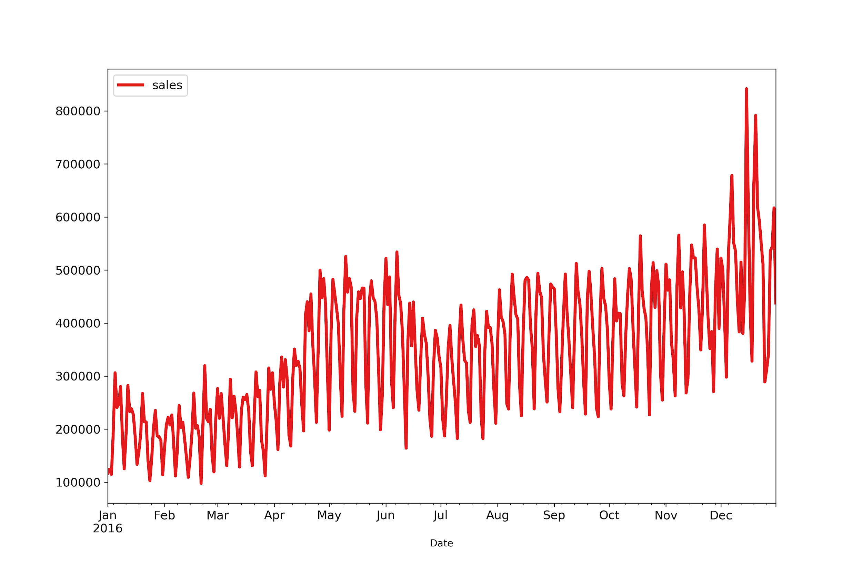

**Fig 1. Drug Sales in 2016**

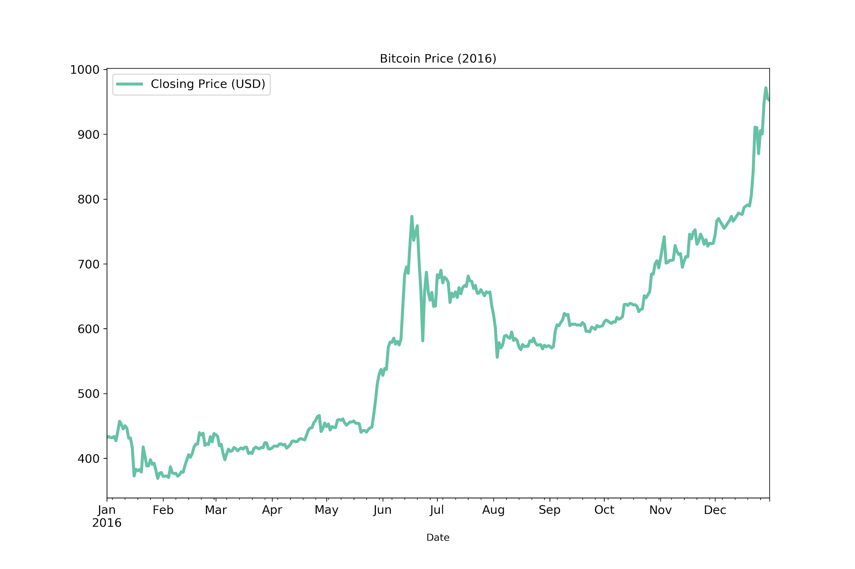

**Fig 2. Bitcoin Prices in 2016**

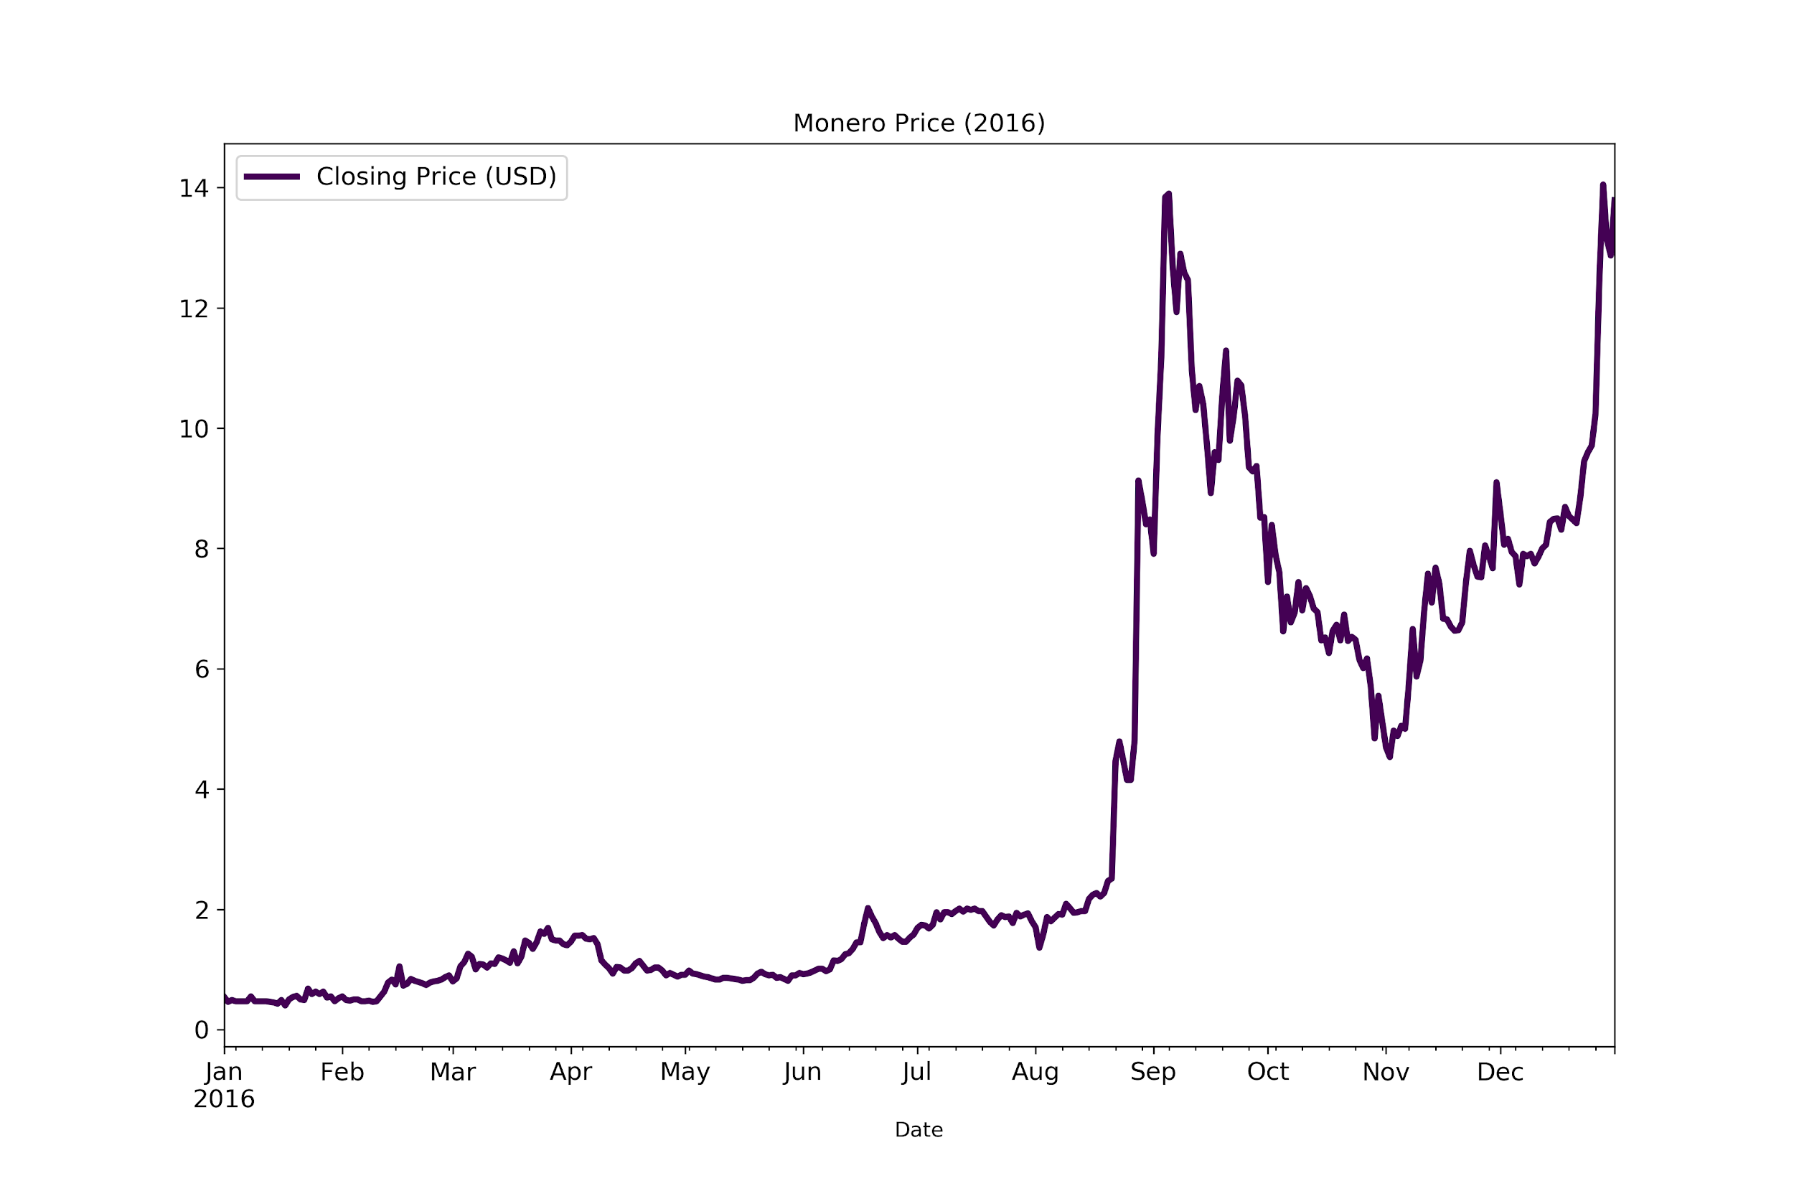

**Fig 3. Monero Prices in 2016**

Further analysing Drug_Sales, we can determine the top countries that ship drugs, the top countries that receive drugs and the top categories of drugs sold.

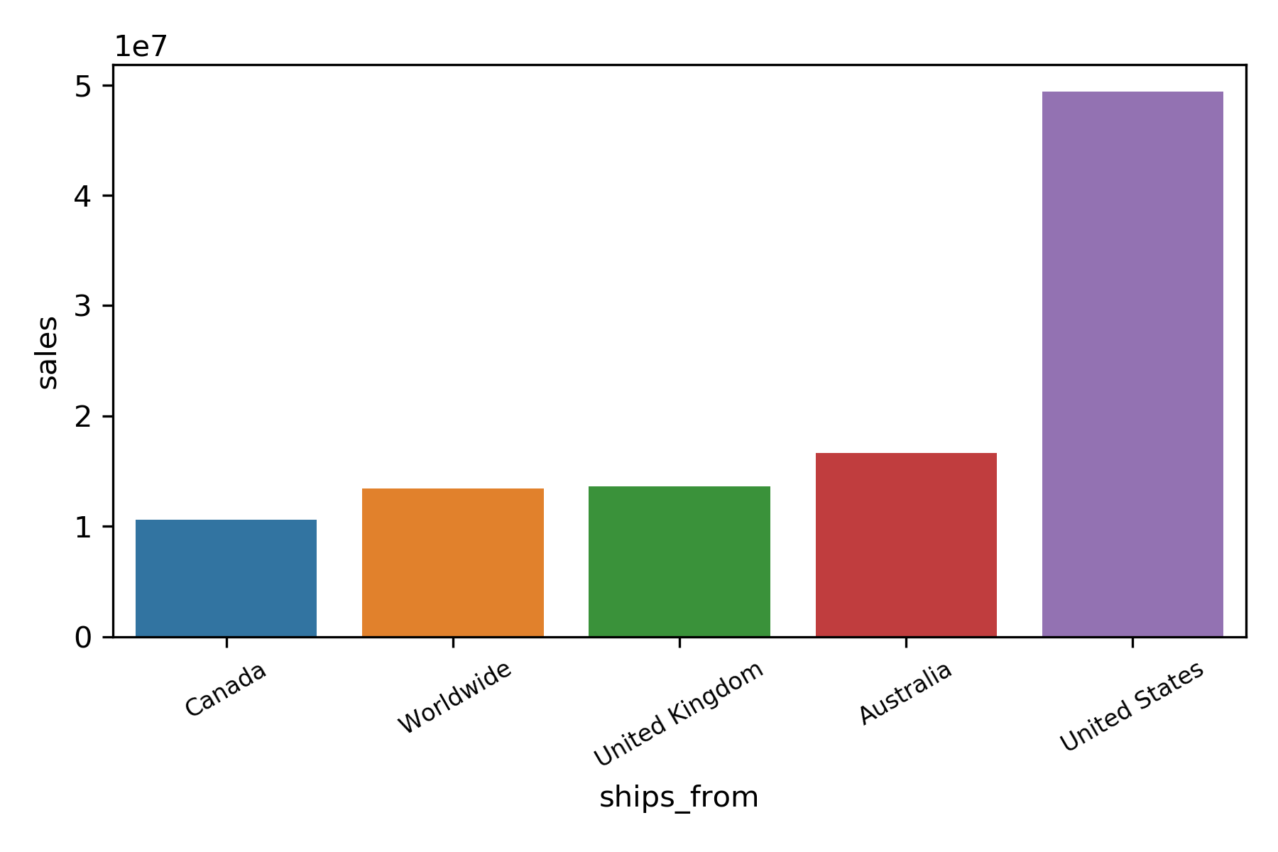

**Fig 4. Drug Sales shipped from (By Country)**

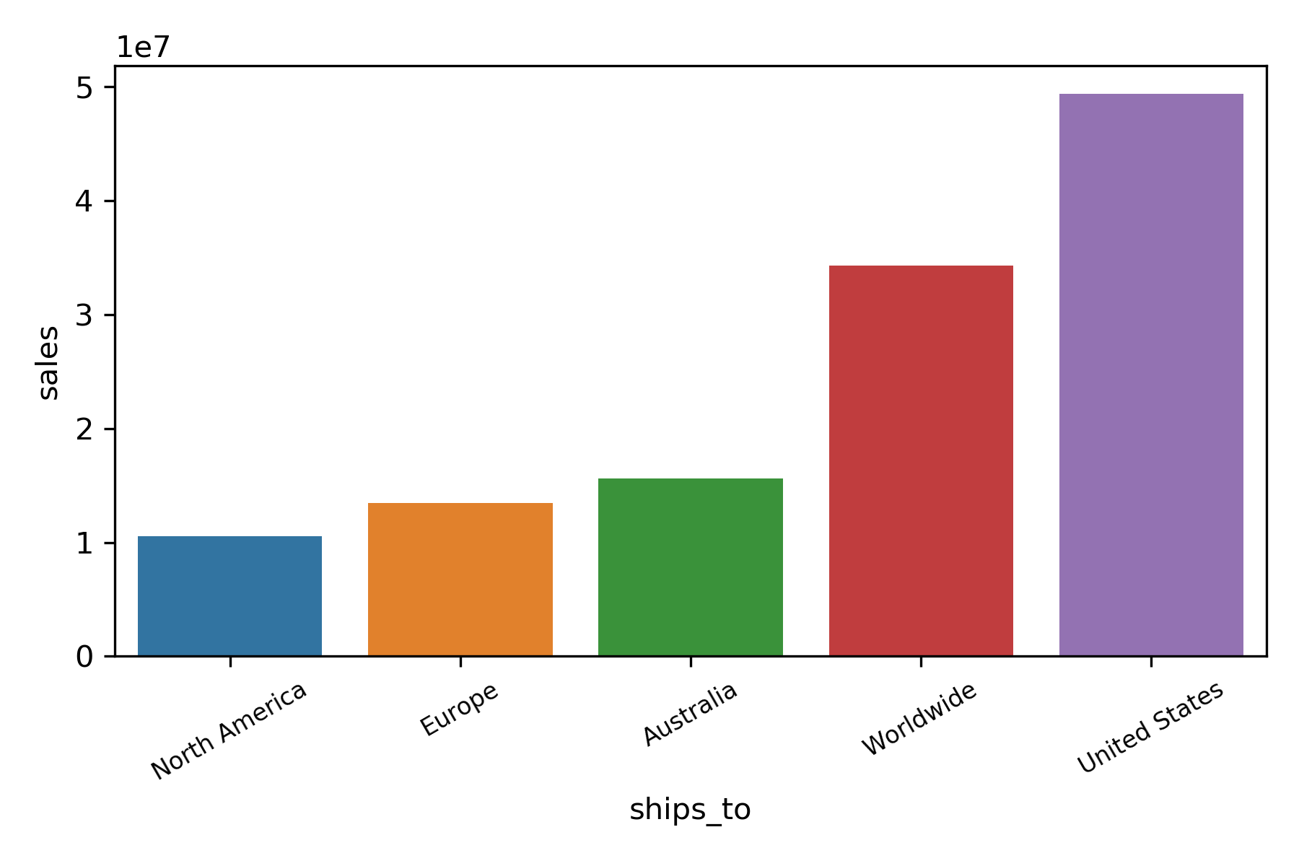

**Fig 5. Drug Sales shipped to (By Country)**

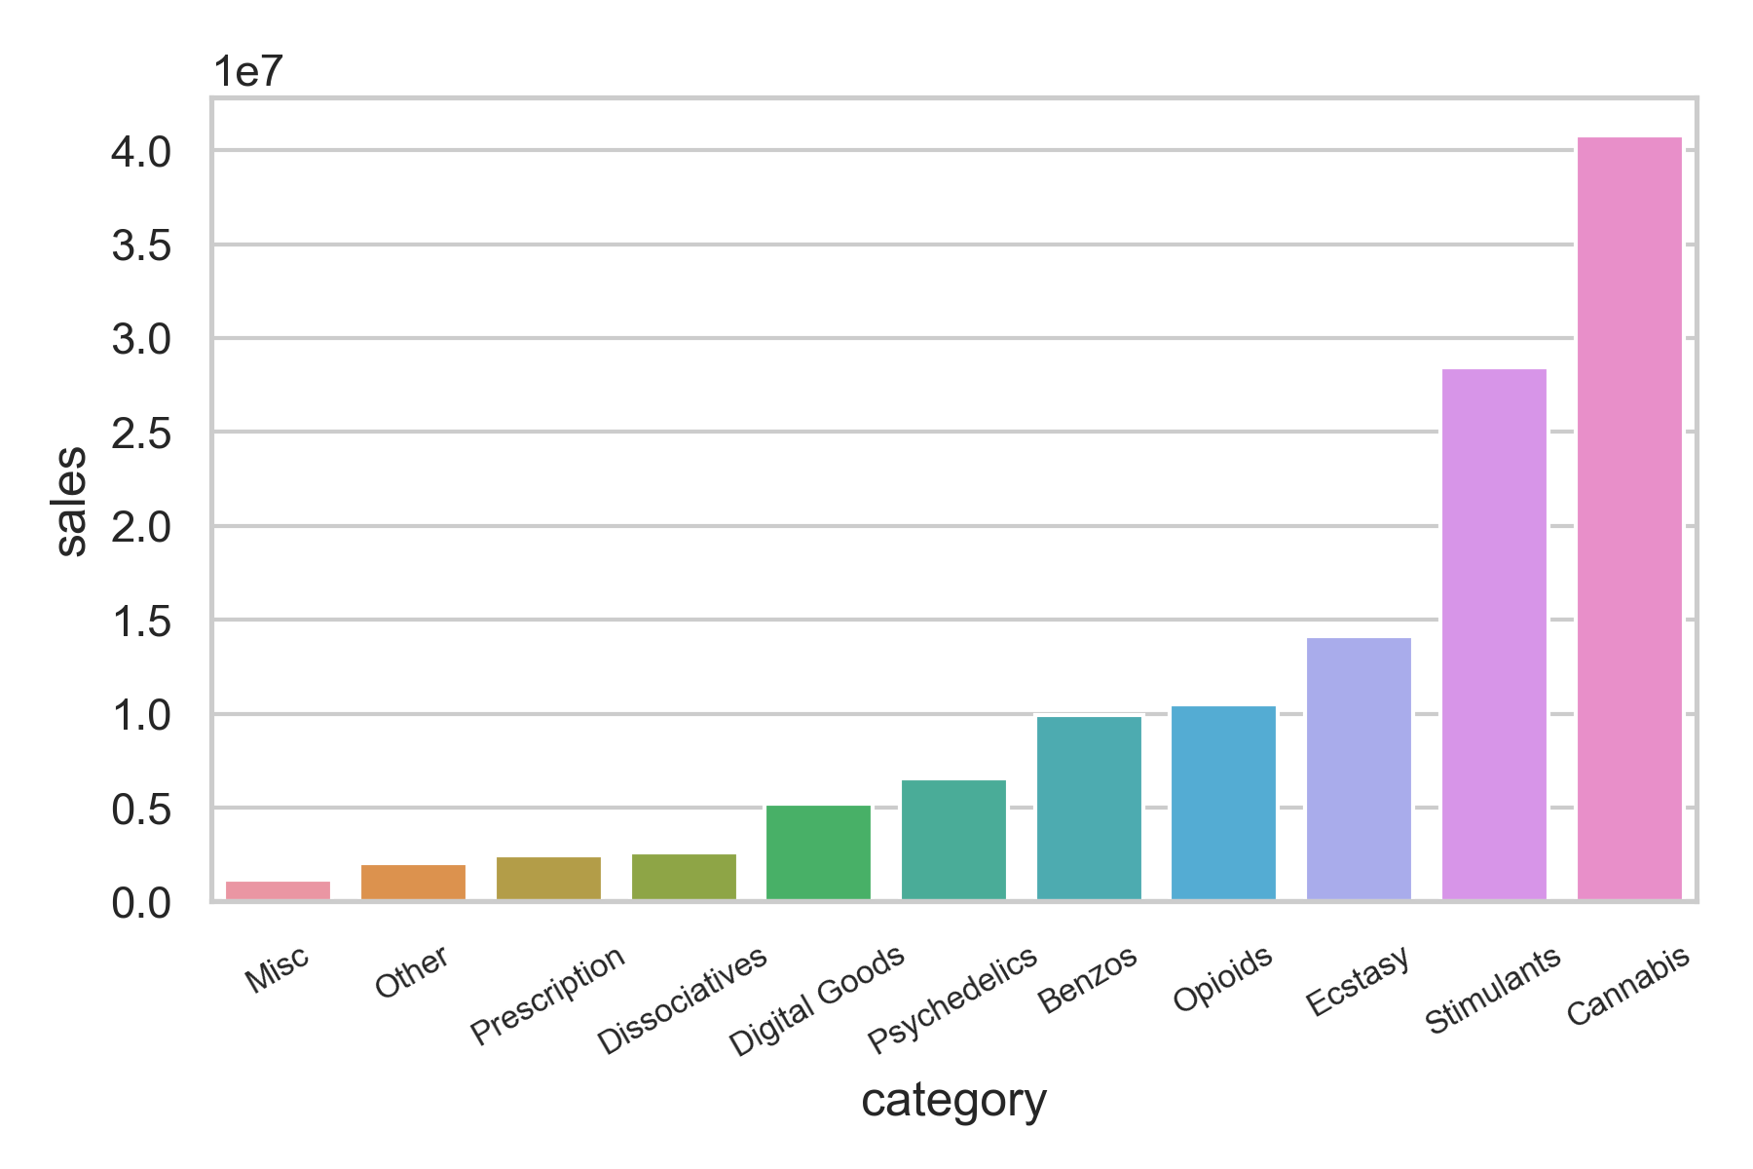

**Fig 6. Drug Sales by Category**

We can see that an overwhelming amount of products are drugs, with the exception of digital goods and dissociatives. We can also see that drug sales are overwhelmingly shipped from and to the United States. According to the category chart, the top 3 drugs sold are Cannabis, Stimulants and Ecstasy. We will be analysing these drug categories in depth later.

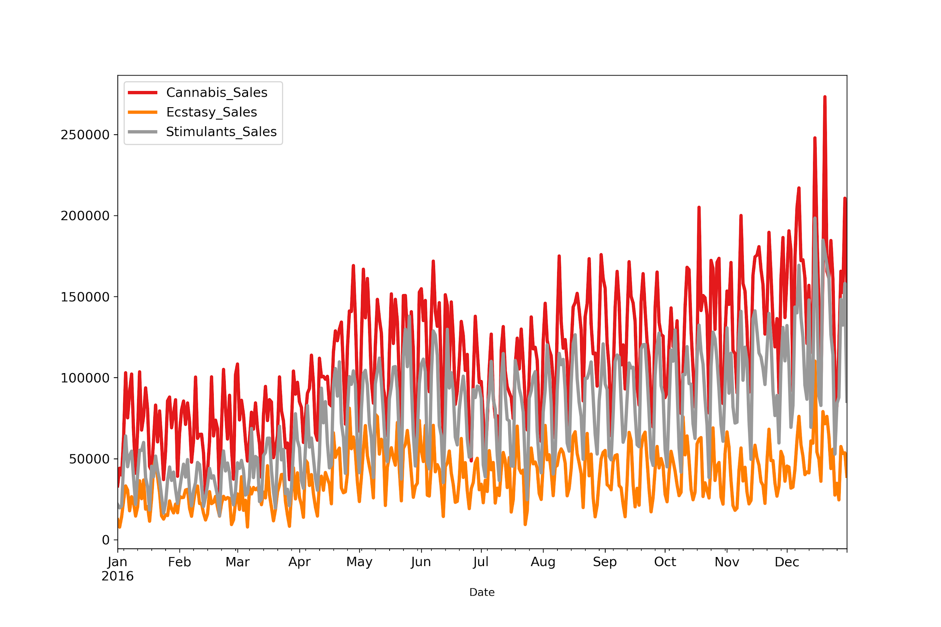

**Fig 7. Drug Sales of top 3 Categories**

# 

**Fig 8. Pair Plot**

The pair plot shows us the pairwise relationships between the variables. For each category of drug sales, we can see that there is a weak correlation between them and the prices of Bitcoin and Monero.

# 

# 

# 2 Vector Autoregressive (VAR) Model

A Vector Autoregressive model comprises multiple time series. An extension of the auto-regressive (AR) model, it involves multiple independent variables and thus includes multiple equations. All variables in a VAR enter the model in the same way, where each variable has an equation explaining its evolution based on its own lagged values, the lagged values of the other model variables, and an error term. Time series models for VAR are usually based on applying the model to stationary series. We will now create a VAR model using Total Drugs, Bitcoin, Monero (Daily).

Total Drugs vs Bitcoin vs Monero (Daily)

## 2.1 Check for stationarity and making the time series stationary

We will now plot the time-series of Bitcoin prices, Monero prices and Drug Sales in 2016. We observe some fairly similar trend patterns in our time series which imply that each of the variables might be a linear function of some past values of itself and the past values of the other variables.

The VAR model requires the time series to be stationary, hence we use the ADF test to check for stationarity. By conducting the ADF test on all datasets and plotting out the time series, we find they are not stationary as all of them have a p-value of more than 0.05.

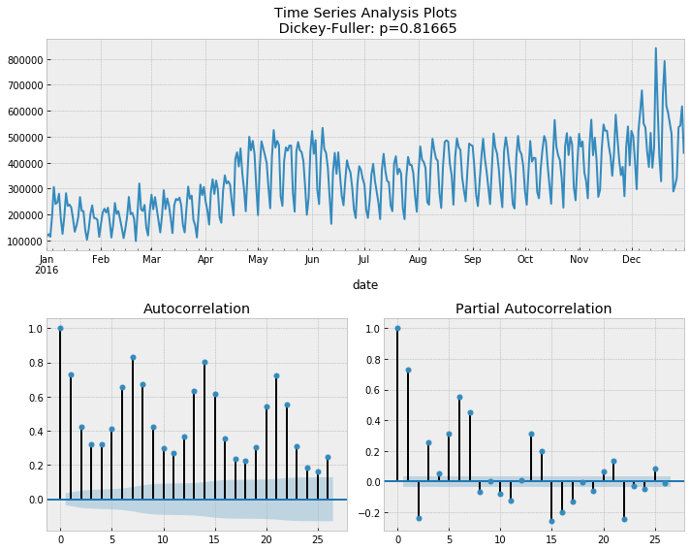

**Fig 9. Drug Sales Time Series Analysis Plots**

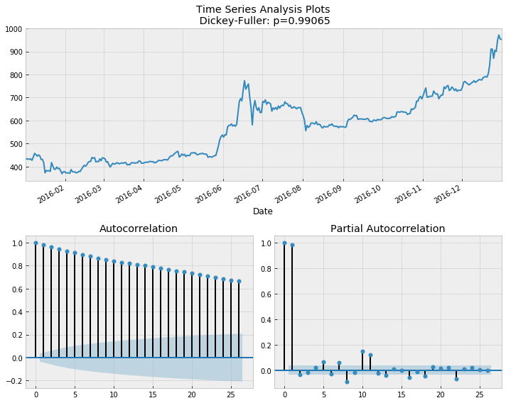

**Fig 10. Bitcoin Price Time Series Analysis Plots**

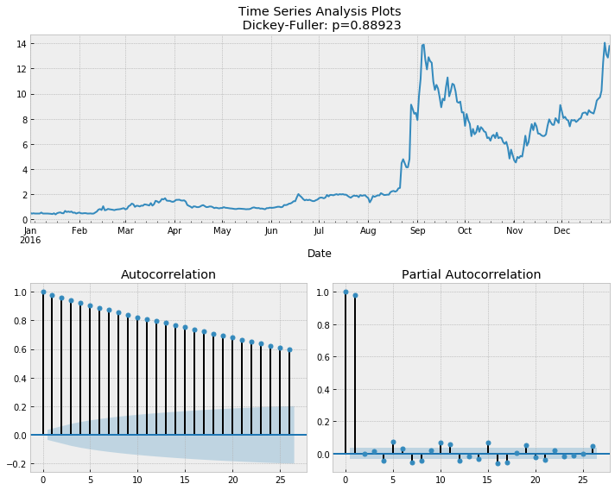

**Fig 11. Monero Price Time Series Analysis Plots**

Results show that all have a p-value of > 0.05. We fail to reject the Null Hypothesis, indicating that the series are non-stationary and contain a unit root. Thus, we difference the data to remove systematic structure from the time series and re-run the ADF test, getting the following results.

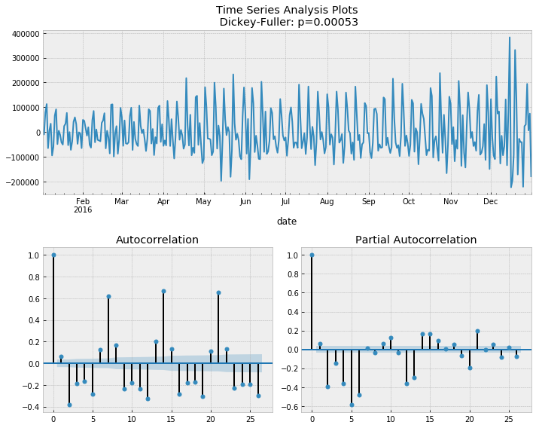

**Fig 12. Drug Sales (Differenced) Time Series Analysis Plots**

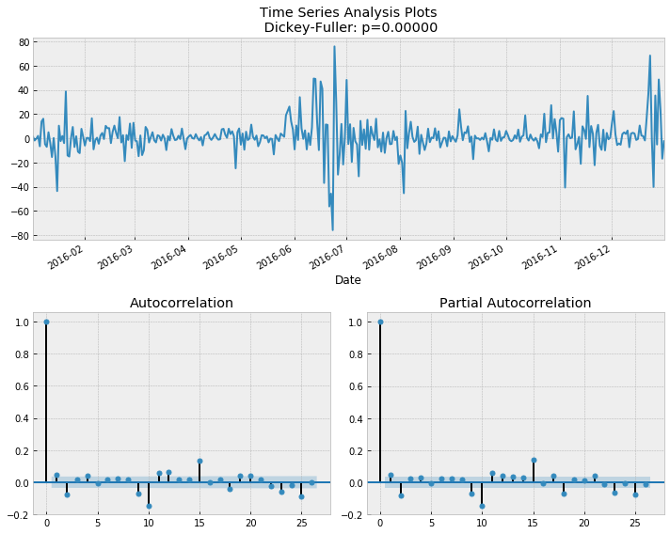

**Fig 13. Bitcoin Price (Differenced) Time Series Analysis Plots**

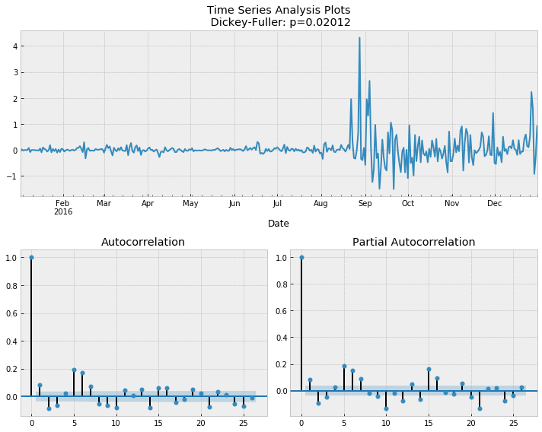

**Fig 14. Monero Price (Differenced) Time Series Analysis Plots**

Since the differenced variables are stationary, we can now proceed to our VAR modelling. We obtain the following information criteria for lag orders up to VAR(10).

## 2.2 Model Determination

|  |
| --- |
|  |

To select the right order of the VAR model, we iteratively fit increasing orders of the VAR model and pick the order that gives a model with least AIC, BIC, FPE or HQIC values. Should there be a tie, we will use AIC since it gives us less errors in forecasting. In this particular case, values of all parameters show us that lag 6 gives us the best model. Hence, we concluded that the lag order 6 is the most appropriate for this model.

## 2.3 Model Estimation

|  |
| --- |
|  |

|  |
| --- |
|  |

We observe a relatively weak correlation among the 3 variables. Since the off-diagonal elements of the estimated correlation matrix are not zero, we therefore decide to investigate further by testing for instantaneous causality between the variables pairwise in the relevant section.

## 2.4 Model Diagnostics:

We conduct a Residual whiteness test using Portmanteau test where H0: The residual autocorrelation up to lag 10 is zero.

|  |
| --- |
|  |

With p-value < 0.05, we reject the null hypothesis, indicating that at least one series is not white noise. We also examine the eigenvalues of the VAR(6) model and observe the roots to be lying outside the unit circle, therefore satisfying the stability condition.

We observe many statistically insignificant independent variables, where at 5% significance level, Drug _Sales is influenced by past values of Drug_Sales, Monero_Price is influenced by past values of Monero_Price, Bitcoin_Price and Drug_Sales while Bitcoin_Price is influenced by past values of Monero_Price.

## 2.5 Structural Analysis

### 2.5.1 Granger Causality

|  |
| --- |
|  |

We observe that the null hypothesis, H0: There is no granger causality, is not rejected between all the variables. Hence there is no granger causation.

We now test instantaneous causality among the variables.

|  |
| --- |
| *$Instant*  *H0: No instantaneous causality between: Monero_Price and Drug_Sales*  *data: VAR object bv12.est*  *Chi-squared = 6.1067, df = 1, p-value = 0.01347*  *$Instant*  *H0: No instantaneous causality between: Drug_Sales and Monero_Price*  *data: VAR object bv12.est*  *Chi-squared = 6.1067, df = 1, p-value = 0.01347*  *$Instant*  *H0: No instantaneous causality between: Drug_Sales and Bitcoin_Price*  *data: VAR object bv23.est*  *Chi-squared = 0.19257, df = 1, p-value = 0.6608*  *$Instant*  *H0: No instantaneous causality between: Bitcoin_Price and Drug_Sales*  *data: VAR object bv23.est*  *Chi-squared = 0.19257, df = 1, p-value = 0.6608* |

We observe that the null hypothesis, H0: There is no instantaneous causality, is rejected for Drug Sales and Monero Price in both directions. Hence, there is instantaneous relations between Drug Sales and Monero Price.

### 2.5.2 Impulse Response Analysis

Our granger causality may not give us the complete story of the interactions between the variables in our system. Therefore, we plot the Impulse Response Functions (IRF) to observe the following impacts on the second variable given a 1-unit shock to the first variable, as well as study the multiplier effects.

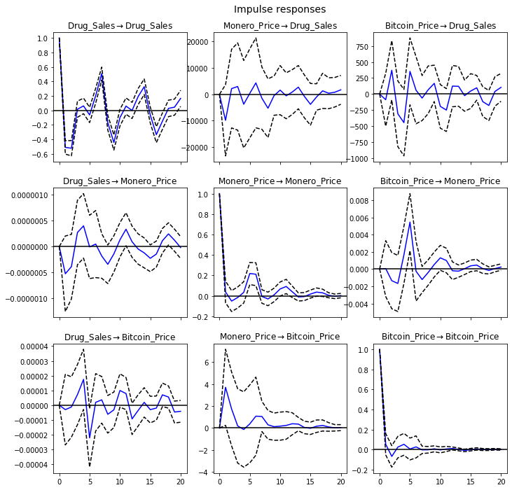

For the short term IRF, we observe that:

* Each variable is unsurprisingly greatly affected by shocks of itself, with a large positive response that decreases to negative quickly and stabilizes at 0.
* Bitcoin_Price has an insignificant negative response to a shock from Drug_Sales which increases quickly and stabilizes at 0
* Drug_Sales has a moderate negative response to a shock from Bitcoin_Price which sharply increases to a significant positive response before it stabilizes at 0

Given that there are contemporaneous relations between Drug_Sales and Monero_Price, we need to observe the orthogonalized IRF between these two variables as the orthogonal IRF measures the isolated effect from a shock in one variable to another.

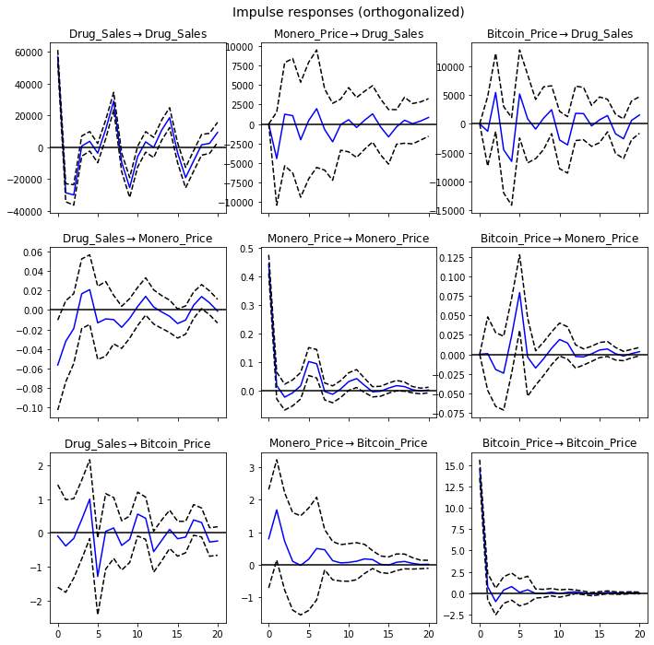

From the short-term orthogonalized IRF, we observe that:

* Monero_Price has a moderate negative response to a shock from Drug_Sales which quickly increases and stabilizes close to 0.
* Drug_Sales has significant negative responses to a shock from Monero_Price before quickly which fluctuates and stabilises with a positive response

As it may be myopic to only observe IRF in the short term, we also plot and observe the cumulative impulse response to observe the long-run effects.

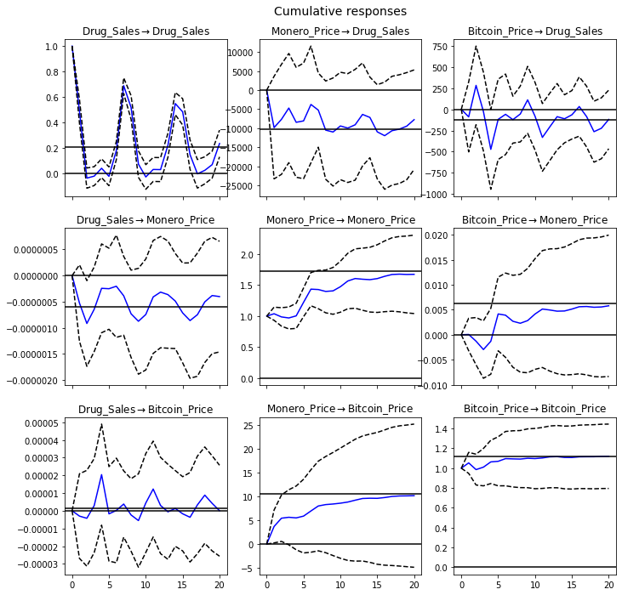

For the long-term IRF, we observe that:

* Similar to the short term IRFs, the long term IRF shows that variables respond positively to shocks from itself. However in the long term, instead of stabilizing at 0, all 3 variables reach some sustained positive response to shocks from itself.
* Bitcoin_Price has an insignificant response to a shock from Drug_Sales which fluctuates minimally and stabilizes close to 0.
* Drug_Sales has a sharp initial positive response to shocks from Bitcoin_Price before gradually decreasing to some sustained negative response.

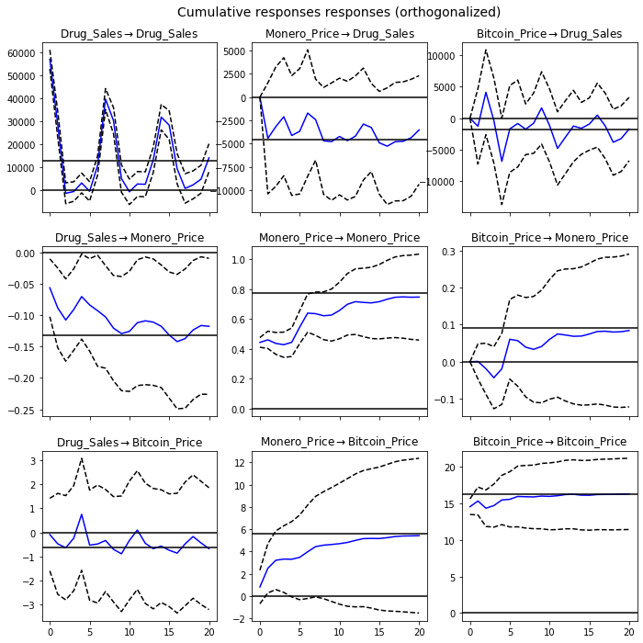

From the long-term orthogonalized IRF, we observe that:

* Monero_Price has an insignificant negative response to a shock from Drug_Sales which gradually increases and stabilizes around 0.
* Drug_Sales has an initial significant negative response to a shock from Monero_Price which gradually increases and stabilises at some positive response.

### 

### 2.5.3 Forecast Error Variance Decomposition

The forecast error variance decomposition (FEVD) measures the fraction of the forecast error variance of a variable that can be attributed to another variable.

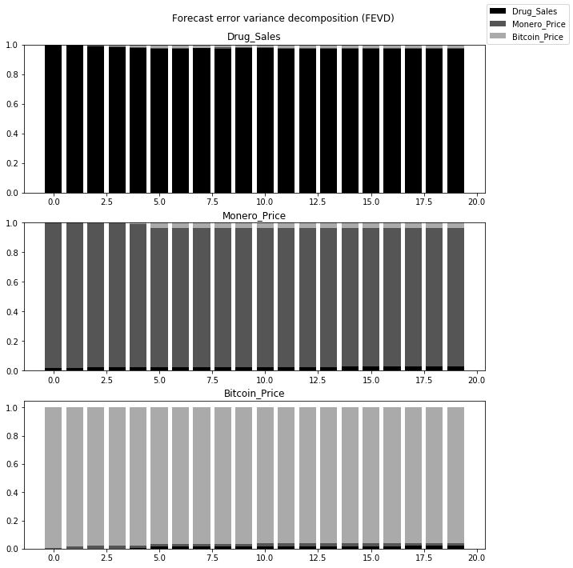

In this FEVD, we observe that:

* Prediction of Drug_sales is largely determined by Drug_sales shocks and minimally affected by Bitcoin_Price
* Prediction of Monero_price is largely determined by Monero_price shocks, with some small influence from Drug_sales and Bitcoin_Price
* Prediction of Bitcoin_Priceis largely largely determined by Bitcoin_Price shocks, with some small influence from Drug_sales and Monero_Price

The variance in the forecast error of all the variables is mainly explained by the variable alone, i.e, the orthogonal shocks to other variables in the system do not increase the variance of your forecast error. These findings are relatively consistent with both our observations from our short term/long-term impulse response functions and granger causality tests.

# 3 Vector Error Cointegration Model

While VAR models are useful for multivariate series analysis, differencing the series to make them stationary comes at a cost of ignoring “long run” relationships between levels. Hence, an alternative would be to implement a Vector Error Cointegration Model (VECM), which combines levels and differences. Before we implement this model, we need to test whether the level regressions are cointegrated using Johansen’s Test.

## 3.1 Model Determination

In order to conduct Johansen’s Cointegration Test, we must first determine the number of lags. We get the number of lags based on the information criteria on our VAR model.

**VAR Order Selection for Drug_Sales and Bitcoin_Price:**

|  |
| --- |
|  |

We can see that lag order 7 gives us the best model.

**VAR Order Selection for Drug_Sales and Monero_Price:**

|  |
| --- |
|  |

We can see that lag order 8 gives us the best model according to the Akaike information criterion (AIC).

## 3.2 Johansen’s Cointegration Test

We first conduct Johansen’s test with the number of lagged differences set as 7 for Drug_Sales and Bitcoin_Price.

**Drug Sales & Bitcoin Price (Daily)**

* No deterministic terms
* 7 lagged differences

|  |
| --- |
|  |

The trace statistics tell us whether the sum of the eigenvalues is 0. The null hypothesis, r=0 gives us a trace statistic of 14.2565, hence the null hypothesis can be rejected at a 95% confidence level, as the magnitude of the trace statistic is greater than the critical value. We can conclude that there is at least one cointegrating vector in the system. Therefore, we can model a VECM for Drug_Sales and Bitcoin_Price.

Now we also conduct Johansen’s test with the number of lagged differences set as 8 for Drug_Sales and Monero_Price.

**Drug Sales & Monero Price (Daily)**

* No deterministic terms
* 8 lagged differences

|  |
| --- |
|  |

In this case, the null hypothesis, r=0 gives us a trace statistic of 6.6159 which is less than 12.3212, the critical value at 95%. Hence the null hypothesis cannot be rejected at a 95% confidence level. We can conclude that there is no cointegrating vector in the system. Therefore, we cannot model a VECM for Drug_Sales and Monero_Price.

## 

## 3.3 Model Estimation

We will now create a VECM model for Drug_Sales and Bitcoin_Price.

|  |
| --- |
|  |

## 3.4 Model Diagnostics

We will now conduct a Residual whiteness test using Portmanteau test where H0: The residual autocorrelation up to lag 10 is zero.

|  |
| --- |
|  |

With p-value < 0.05, we reject the null hypothesis, indicating that at least one series is not white noise. We also examine the eigenvalues of the VECM model and observe the roots to be lying outside the unit circle, therefore satisfying the stability condition.

# 4 Forecasting

Having understood the methodology to determine a VAR and VECM model, we shall now use them to forecast **Bitcoin Price (Daily) using Drug Sales**. We first fit the respective models onto the relevant datasets, where we split it into training and testing data using a 70-30 ratio. The training data, which dates from 1 January 2016 to 12 September 2016, will be used to forecast values that will be compared against the actual values present in the testing data, which dates from 13 September 2016 to 31 December 2016. Then, we will evaluate the models’ accuracy.

## 4.1 VAR Model

For forecasting using a VAR model, it is important to note that we have used differenced values. Hence, we need to de-difference the data in order to return to its original scale. We have rectified this problem by taking the cumulative sum of our differenced data to produce the following forecast:

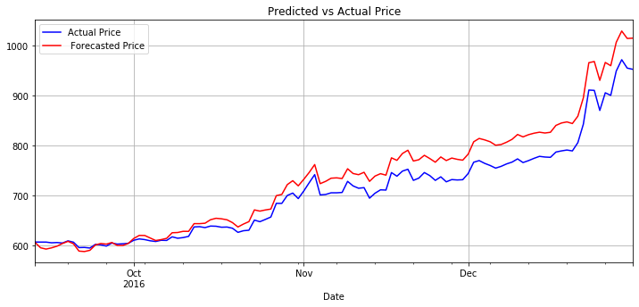

**Fig 15. VAR model forecast of Bitcoin prices**

## 4.2 VECM

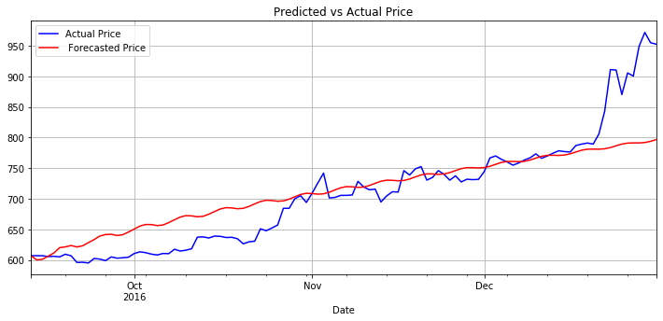

**Fig 16. VECM forecast of Bitcoin prices**

## 4.3 Evaluation

|  |  |  |  |  |
| --- | --- | --- | --- | --- |
|  | Bias | MAE | MSE | RMSE |
| VAR | -26.174101 | 27.558742 | 1112.841283 | 33.359276 |
| VECM | -4.125307 | 31.949196 | 2332.958533 | 48.300709 |

We can see that our VAR forecast is more accurate based on RMSE. While the bias is more negative as it consistently forecasts prices lower than actual, it is able to forecast the trend of actual prices more accurately. For our VECM forecast, the model fails to predict the sharp increase in prices at the end of December. Hence, VAR is the better model for predicting daily Bitcoin Prices using Total Drug sales.

# 

# 5 Exploring Further Relationships

We have successfully concluded that daily Drug Sales may be used to predict Bitcoin Price using a VAR model. However, this may not be the best model, and we can enrich our analyses by using different models with different permutations categorised by total drugs, cannabis, stimulants or ecstasy, aggregated over daily, weekly and biweekly time periods. To find the most ideal variables, we have decided to use Granger Causality to identify them.

As Granger Causality is a statistical hypothesis test that is more easily quantifiable compared to Impulse Response Analysis and FEVD, we will use this metric to determine which variables are more suitable to be used to forecast our crypto-currency prices. In particular, we create 3 matrices with multiple permutations categorised by total drugs, cannabis, stimulants or ecstasy, aggregated over daily, weekly and biweekly time periods.

The results of Granger-causality p-values are summarised by using the in the following matrices, with our full process moved down to the appendix in section 7 in the report.

## 5.1 Determine Forecast Variables

### 5.1.1 DailyGranger Causality Matrix (P-value):

|  |  |  |  |  |  |  |
| --- | --- | --- | --- | --- | --- | --- |
| x granger causes y | TotalDrugs | Cannabis | Stimulants | Ecstasy | Bitcoin | Monero |
| Total Drugs | - | - | - | - | 0.234 | 0.144 |
| Cannabis | - | - | - | - | 0.102 | 0.113 |
| Stimulants | - | - | - | - | 0.550 | 0.048 |
| Ecstasy | - | - | - | - | 0.514 | 0.024 |
| Bitcoin | 0.322 | 0.698 | 0.255 | 0.354 | - | - |
| Monero | 0.689 | 0.496 | 0.609 | 0.896 | - | - |

### 

### 5.1.2 Weekly Granger Causality Matrix (P-value):

|  |  |  |  |  |  |  |
| --- | --- | --- | --- | --- | --- | --- |
| x granger cause y | Total Drugs | Cannabis | Stimulants | Ecstasy | Bitcoin | Monero |
| Total Drugs | - | - | - | - | 0.021 | 0.130 |
| Cannabis | - | - | - | - | 0.024 | 0.132 |
| Stimulants | - | - | - | - | 0.404 | 0.607 |
| Ecstasy | - | - | - | - | 0.029 | 0.178 |
| Bitcoin | 0.100 | 0.328 | 0.117 | 0.094 | - | - |
| Monero | 0.742 | 0.912 | 0.718 | 0.311 | - | - |

### 5.1.3 BiweeklyGranger Causality Matrix (P-value):

|  |  |  |  |  |  |  |
| --- | --- | --- | --- | --- | --- | --- |
| x granger cause y | Total Drugs | Cannabis | Stimulants | Ecstasy | Bitcoin | Monero |
| Total Drugs | - | - | - | - | 0.738 | 0.303 |
| Cannabis | - | - | - | - | 0.058 | 0.191 |
| Stimulants | - | - | - | - | 0.300 | 0.248 |
| Ecstasy | - | - | - | - | 0.399 | 0.562 |
| Bitcoin | 0.515 | 0.313 | 0.825 | 0.575 | - | - |
| Monero | 0.983 | 0.753 | 0.957 | 0.725 | - | - |

### 

We can see that there are five p-values less than 0.05. Hence we can conclude that:

For the **Daily** time period:

* Stimulant sales granger causes Monero Price
* Ecstasy sales granger causes Monero Price.

For the **Weekly** time period:

* Total Drug sales granger causes Bitcoin price
* Cannabis sales granger causes Bitcoin price
* Ecstasy sales granger causes Bitcoin price.

We do not observe any granger causality of our any type of drug sales on cryptocurrency prices for the **Biweekly** category.

## 5.2 Choosing Best Forecasting Models

We can now proceed with forecasting for the 5 relationships mentioned earlier by building the relevant models here.

### 5.2.1 Model Determination

Once again, we will conduct Johansen’s Cointegration Test for the 5 variable-pairs. This is to determine if VECM can be a suitable model to forecast for Bitcoin and Monero prices. After determining the number of lags based on the information criteria on our VAR models, we will use the number of lags in our Johansen’s Cointegration Test. Using the same process as 3.1, we have summarised our lag orders as follows:

|  |  |
| --- | --- |
| Variable-Pair: | Lag Order: |
| Stimulant Sales & Monero Price (Daily) | 6 |
| Ecstasy Sales & Monero Price (Daily) | 6 |
| Drug Sales & Bitcoin Price (Weekly) : | 9 |
| Cannabis Sales & Bitcoin Price (Weekly) | 9 |
| Ecstasy Sales & Bitcoin Price (Weekly) | 10 |

### 5.2.2 Johansen’s Cointegration Test

Stimulants Sales & Monero Price (Daily) :

* No deterministic terms
* 6 lagged differences

|  |
| --- |
|  |

Ecstasy Sales & Monero Price (Daily) :

* No deterministic terms
* 6 lagged differences

|  |
| --- |
|  |

Drug Sales & Bitcoin Price (Weekly) :

* No deterministic terms
* 9 lagged differences

|  |
| --- |
|  |

Cannabis Sales & Bitcoin Price (Weekly) :

* No deterministic terms
* 9 lagged differences

|  |
| --- |
|  |

Ecstasy Sales & Bitcoin Price (Weekly) :

* No deterministic terms
* 10 lagged differences

|  |
| --- |
|  |

Here, we can see that in all five models, we accept H0: the rank equal to 0, and reject the H0: the rank is less than or equal to 1. Hence, cointegration does not exist since there is no cointegrating vector. We therefore cannot use VECM, and we will use VAR modelling instead.

### 

### 5.2.3 Forecasting

Using the same methodology to forecast daily Bitcoin Price using overall Drug Sales, we will split our data into training and testing using a 70-30 ratio and forecast crypto-currency prices for 13 September 2016 to 31 December 2016. After which, we will evaluate the various models’ accuracy using various error metrics as shown below.

Here are the plots of forecasted vs actual prices for the various models.

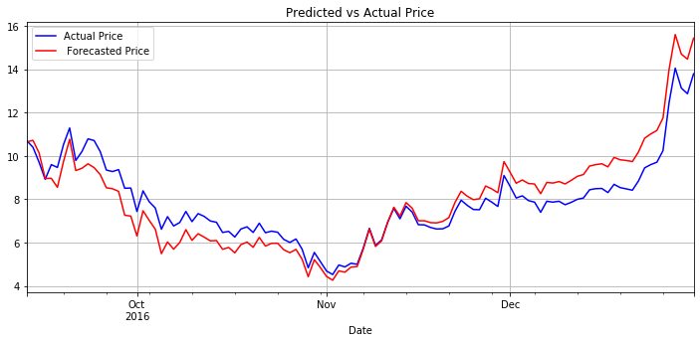

**Fig 17. Forecast results for Stimulants sales & Monero price (Daily) model**

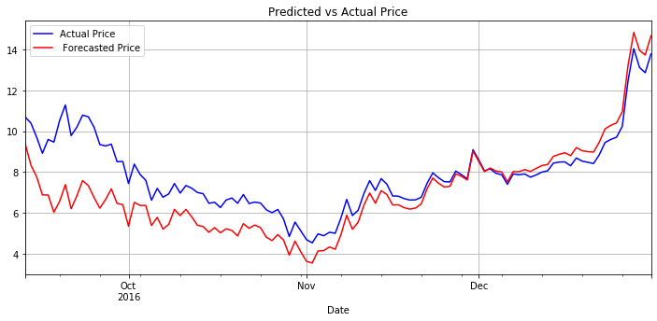

**Fig 18. Forecast results for Ecstasy sales & Monero price (Daily) model**

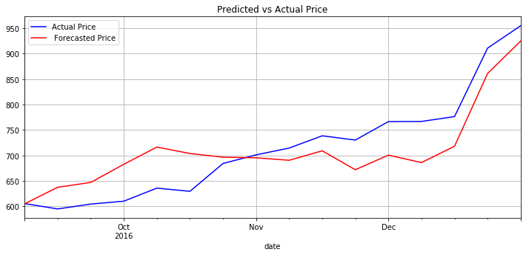

**Fig 19. Forecast results for Drug sales & Bitcoin price (Weekly) model**

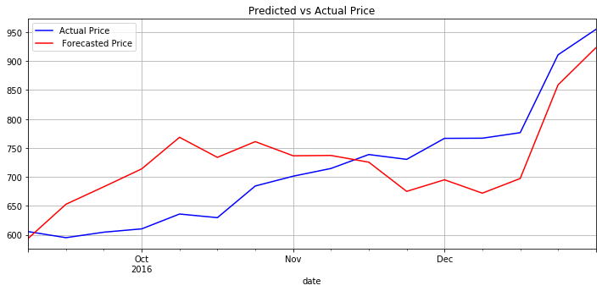

**Fig 20. Forecast results for Cannabis sales & Bitcoin price (Weekly) model**

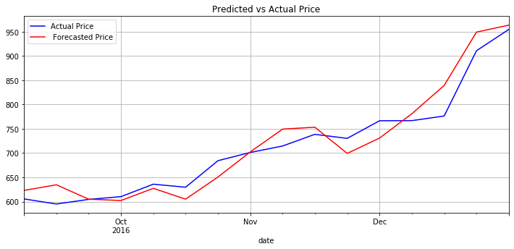

**Fig 21. Forecast results for Ecstasy sales & Bitcoin price (Weekly) model**

After forecasting, we will now access the best model for predicting Monero and Bitcoin respectively.

We have used the Bias (Mean Bias Error), Mean Absolute Error (MAE), Mean Squared Error (MSE) and Root Mean Squared Error (RMSE) to select the best model for forecasting prices of the respective cryptocurrencies. The chosen models will be highlighted in green.

|  |  |  |  |  |
| --- | --- | --- | --- | --- |
|  | Bias | MAE | MSE | RMSE |
| Stimulants sales & Monero price (**Daily**) | -0.056129 | 0.735656 | 0.722865 | 0.850215 |
| Ecstasy sales & Monero price (**Daily**) | 0.854851 | 1.098461 | 2.074863 | 1.440438 |

Looking at the summarised error metrics of the models used for daily data, we will be using the Stimulants sales & Monero price model to predict daily prices of Monero.

|  |  |  |  |  |
| --- | --- | --- | --- | --- |
|  | Bias | MAE | MSE | RMSE |
| Drug sales & Bitcoin price (**Weekly**) | 4.865452 | 45.477636 | 2722.334352 | 52.175994 |
| Cannabis sales & Bitcoin price (**Weekly**) | -12.597467 | 63.791501 | 5235.103646 | 72.354016 |
| Ecstasy sales & Bitcoin price (**Weekly**) | -5.694238 | 23.373664 | 820.521055 | 28.644739 |

Looking at the summarised error metrics of the models used for weekly data, we will be using the Ecstasy sales & Bitcoin price model to predict the weekly prices of Bitcoin.

# 

## 5.3 Evaluation

We will now use the chosen models in the previous section to forecast actual Monero daily and Bitcoin weekly prices in January 2017.

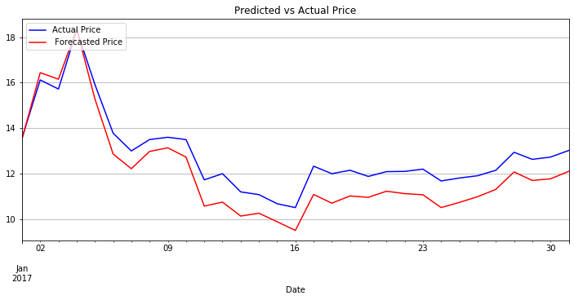

**Fig 22. Forecast results for Stimulants sales & Monero price (Daily) model**

**in Jan 2017**

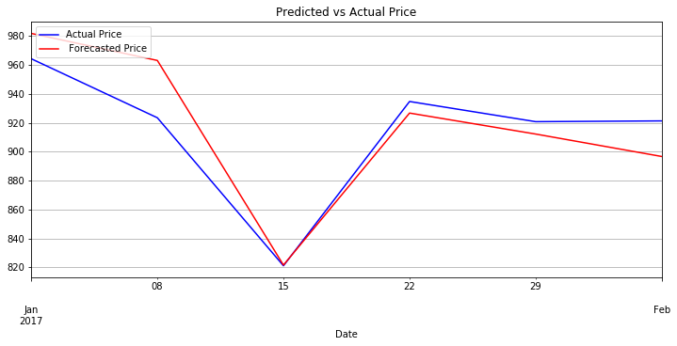

**Fig 23. Forecast results for Ecstasy sales & Bitcoin price (Weekly) model**

**in Jan 2017**

|  |  |  |  |  |
| --- | --- | --- | --- | --- |
|  | Bias | MAE | MSE | RMSE |
| Stimulants sales & Monero price (**Daily**) | 0.794986 | 0.845911 | 0.815795 | 0.903214 |
| Ecstasy sales & Bitcoin price (**Weekly**) | -2.741331 | 16.463605 | 436.728769 | 20.898057 |

When we compare our models, we see that daily Stimulant Sales forecasting for Monero Prices is extremely accurate, with all error metric values below 1. For weekly Ecstasy Sales forecasting weekly Bitcoin Prices, it still has decent forecasting accuracy, with the metric values actually decreasing when compared to our training data.

# 6 Conclusion

## 6.1 Insights

Our key insight in predicting cryptocurrency prices lies in one of the most fundamental concepts in Economics - The theory of Demand. The high volume of drug sales on the Dark Web have fueled the demand for Bitcoin and Monero. Thus, their prices increase.

After evaluating the accuracy of our forecasting models, we can conclude that Daily Stimulant Sales is an excellent predictor of Monero Prices. Daily Ecstasy Sales is also a good predictor of Monero Prices. We can postulate that transactions of Stimulants and Ecstasy over the Dark Web in 2016 heavily utilised Monero, giving rise to an increase in demand of Monero. Subsequently, this caused an increase in the price of Monero.

For Bitcoin prices, we can use weekly Ecstasy Sales for predictions. While not as strong as our Monero model, it still gives us some insight into the high usage of Bitcoin on the Dark Web market.

## 6.2 Limitations

As with any predictions made in the financial world, there are bound to be limitations. Classical economists say this is due to market clearing. Cryptocurrency prices specifically should be taken with a hint of skepticism as they are extremely volatile.

In the first place, data on drug sales on the dark web usually would not be available to us in real time, hence the lack of sufficient analytical support does not enable accurate predictions of Bitcoin or Monero prices. Additionally, we will need more data of Dark Web Transactions from 2017 to 2019 in order to refine and provide more long-term analyses.

Secondly, there are multiple factors affecting cryptocurrency prices that forecasters may not know about as it is a very sophisticated and challenging environment. There are also many factors affecting cryptocurrency prices that we did not include, which may lead to possible omitted variable bias. With imperfect information available, it can be very difficult to accurately predict prices in the nascent digital currency space.

Lastly, there are also certain limitations of the VAR model. While easy to implement, the methods such as computing impulse response functions may not be as accurate if some variables are highly persistent. VAR models also have limitations on structural inference and policy analysis when the objective is to find causal relations among macroeconomic variables. Furthermore, they rely on a small and fixed number of predictors which might have poor resilience to market variations. Hence, VAR model forecasting should be taken with a pinch of salt.

Nevertheless, with more data and a sound knowledge of the market conditions, one can utilise multiple models to predict the prices of cryptocurrencies. As the great British statistician [George E. P. Box](https://en.wikipedia.org/wiki/George_E._P._Box) once said, “essentially, all models are wrong, but some are useful”.

# 

# 7 Appendix

## DAILY

### Cannabis vs Bitcoin vs Monero (Daily)

**Cannabis**

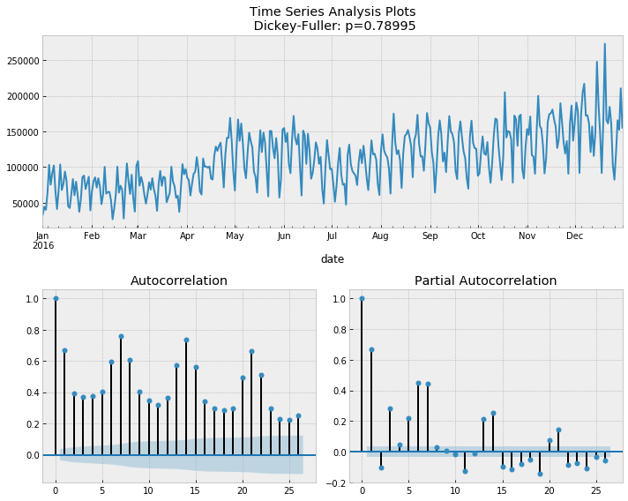

**Cannabis Differenced**

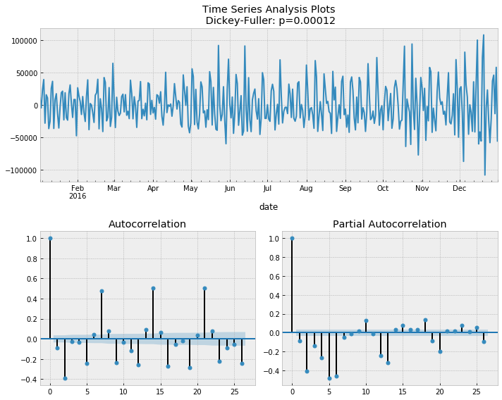

### Model Determination:

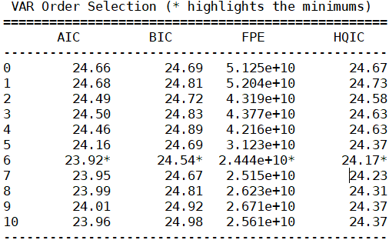

### Model Estimation:

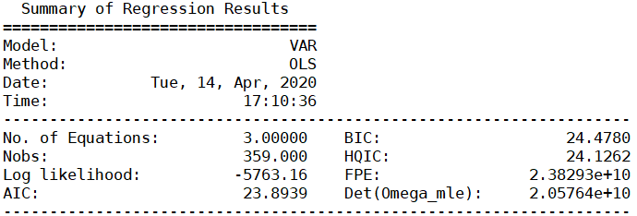

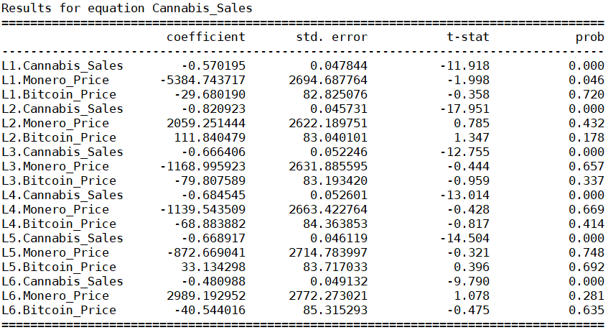

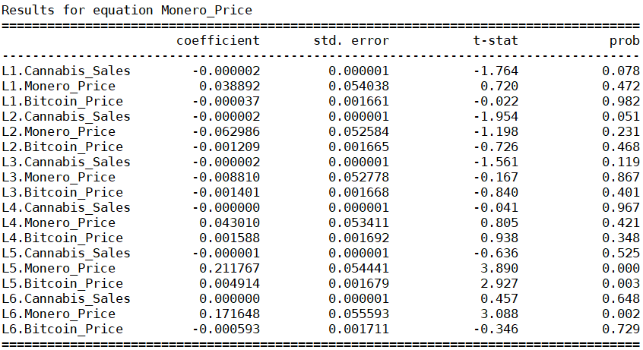

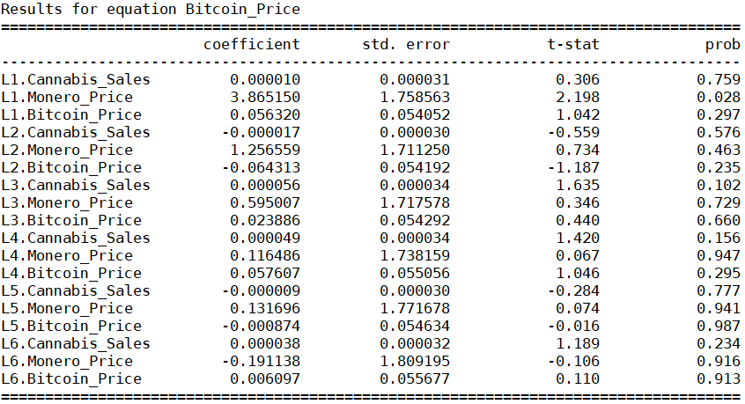

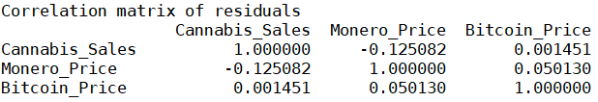

### Model Diagnostics:

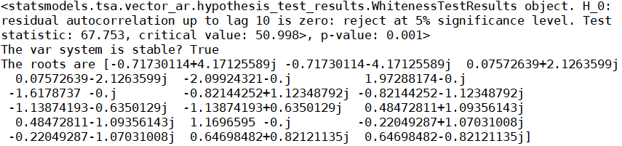

### Structural Analysis:

#### Granger Causality

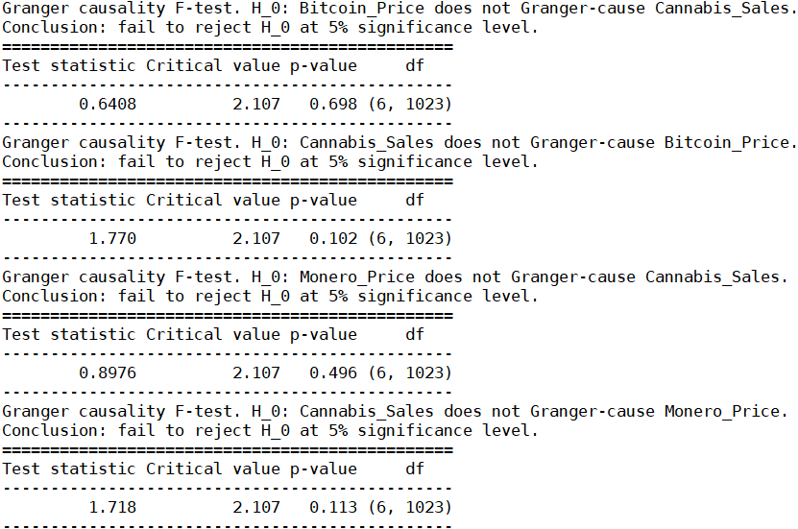

*$Instant*

*H0: No instantaneous causality between: Monero_Price and cannabis_Sales*

*data: VAR object bv12.est*

*Chi-squared = 5.2514, df = 1, p-value = 0.02193*

*$Instant*

*H0: No instantaneous causality between: cannabis_Sales and Monero_Price*

*data: VAR object bv12.est*

*Chi-squared = 5.2514, df = 1, p-value = 0.02193*

*$Instant*

*H0: No instantaneous causality between: cannabis_Sales and Bitcoin_Price*

*data: VAR object bv23.est*

*Chi-squared = 0.032713, df = 1, p-value = 0.8565*

*$Instant*

*H0: No instantaneous causality between: Bitcoin_Price and cannabis_Sales*

*data: VAR object bv23.est*

*Chi-squared = 0.032713, df = 1, p-value = 0.8565*

Fail to reject null hypothesis that there are no contemporaneous relationships between Cannabis_Sales and Monero_Prices in both directions

#### Impulse Response Analysis

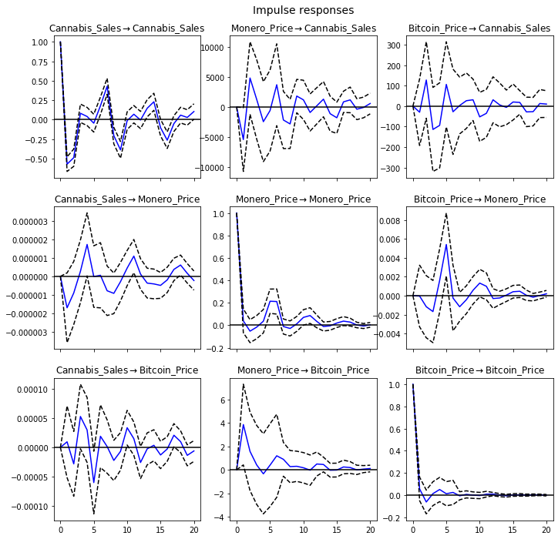

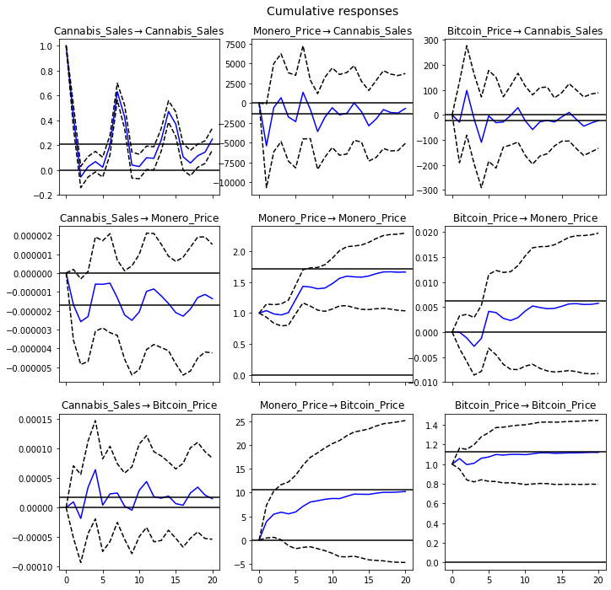

#### Forecast Error Variance Decomposition (FEVD)

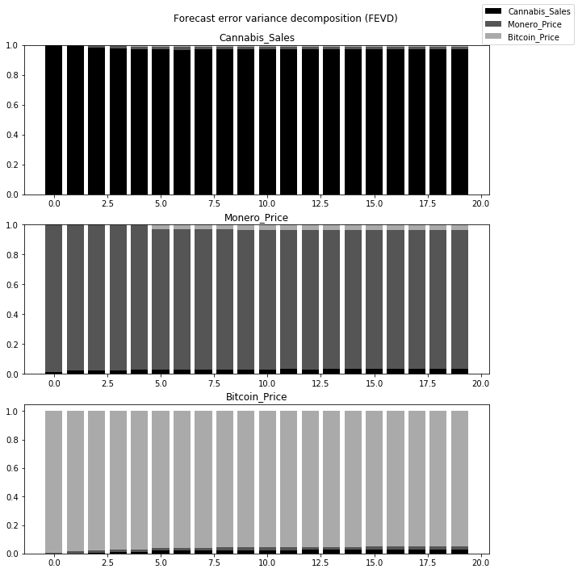

### Stimulants vs Bitcoin vs Monero (Daily)

Stimulants

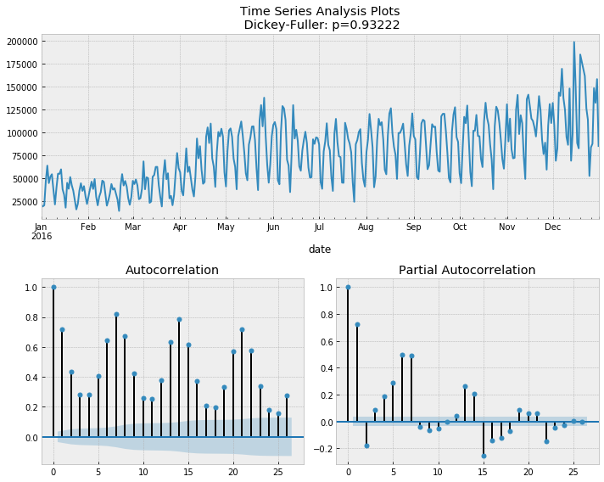

Stimulants Differenced

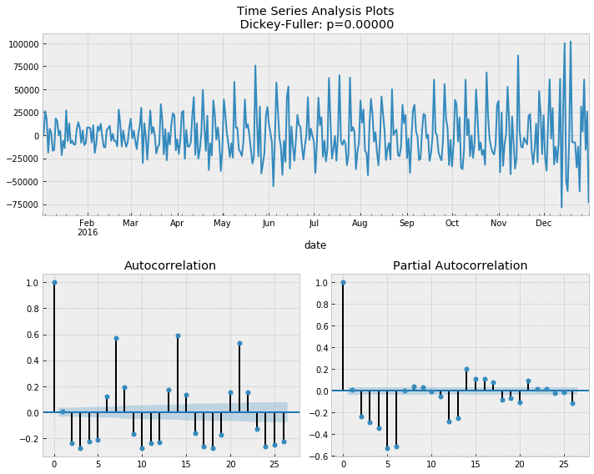

### Model Determination:

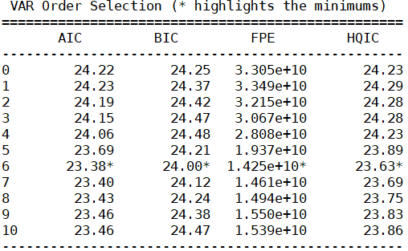

### Model Estimation:

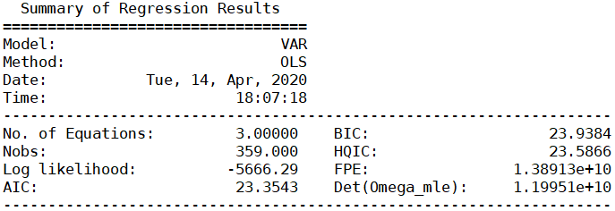

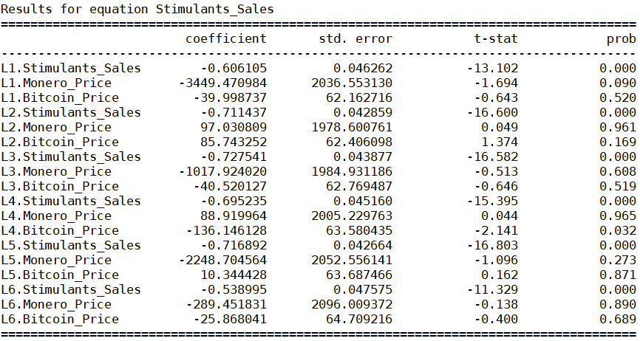

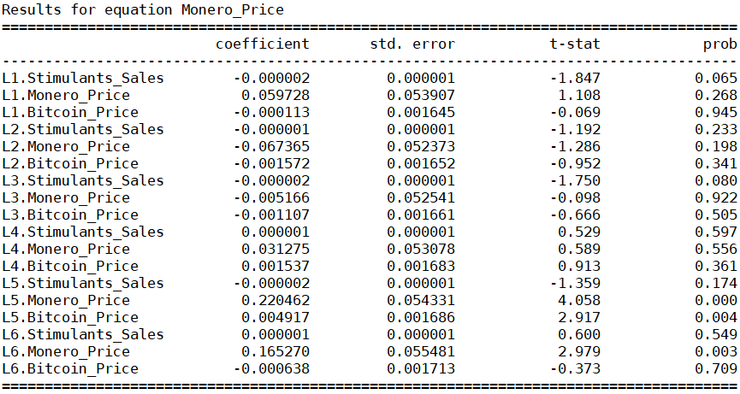

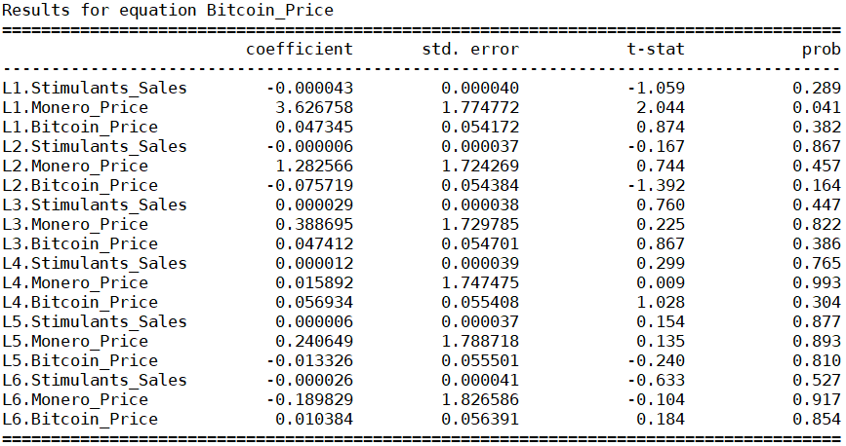

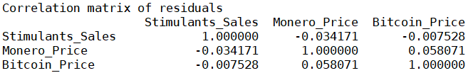

### Model Diagnostics:

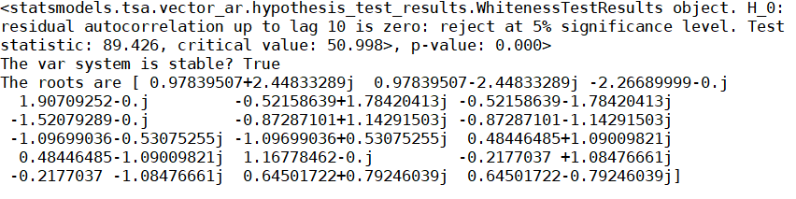

### Structural Analysis:Granger Causality

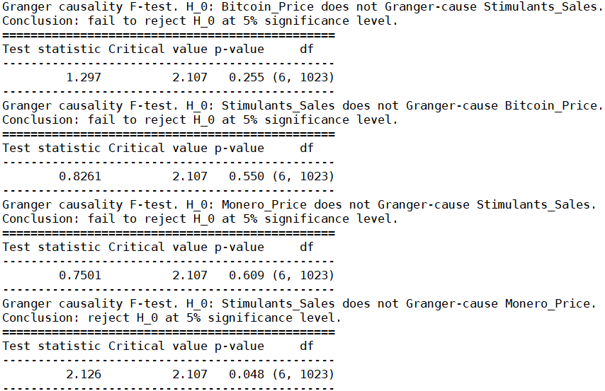

From the p-values of the Granger Causality tests, we can see that Stimulants_Sales granger-causes Monero_Price.

*$Instant*

*H0: No instantaneous causality between: Monero_Price and stimulants_Sales*

*data: VAR object bv12.est*

*Chi-squared = 0.6014, df = 1, p-value = 0.438*

*$Instant*

*H0: No instantaneous causality between: stimulants_Sales and Monero_Price*

*data: VAR object bv12.est*

*Chi-squared = 0.6014, df = 1, p-value = 0.438*

*$Instant*

*H0: No instantaneous causality between: stimulants_Sales and Bitcoin_Price*

*data: VAR object bv23.est*

*Chi-squared = 0.13035, df = 1, p-value = 0.7181*

*$Instant*

*H0: No instantaneous causality between: Bitcoin_Price and stimulants_Sales*

*data: VAR object bv23.est*

*Chi-squared = 0.13035, df = 1, p-value = 0.7181*

We observe that the null hypothesis that there are no contemporaneous relationships failed to be rejected for all variables

#### Impulse Response Analysis

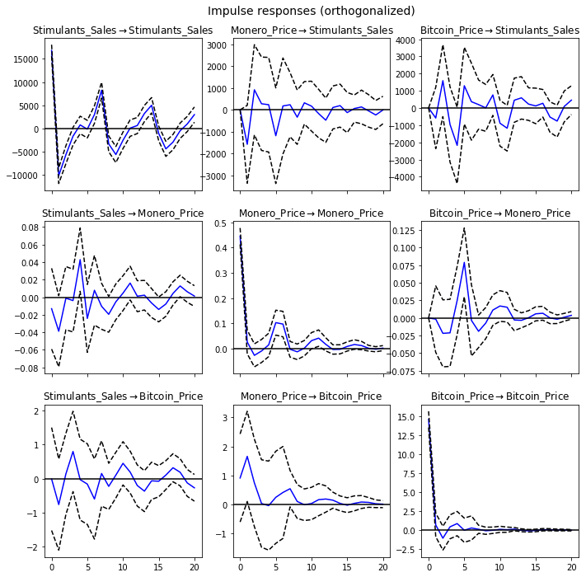

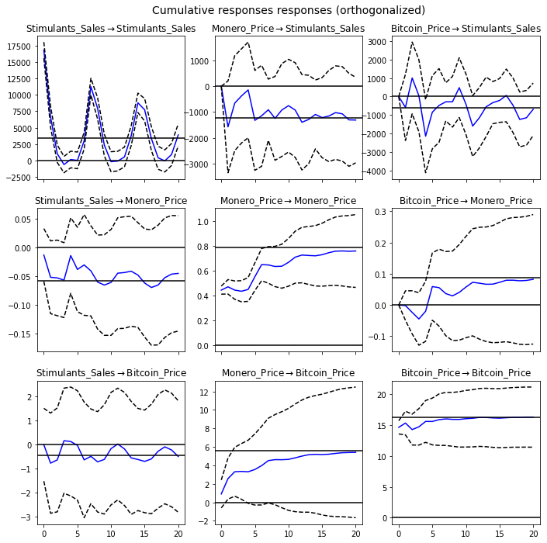

#### Forecast Error Variance Decomposition (FEVD)

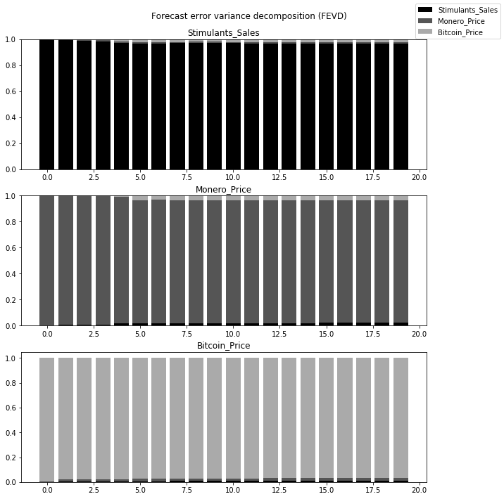

### Ecstasy vs Bitcoin vs Monero (Daily)

Ecstasy

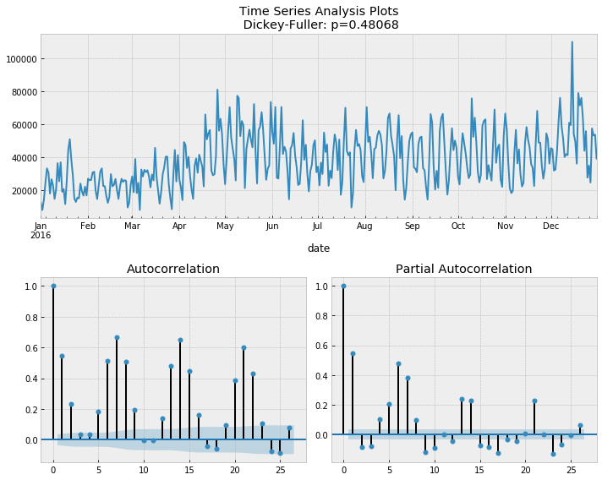

Ecstasy Differenced

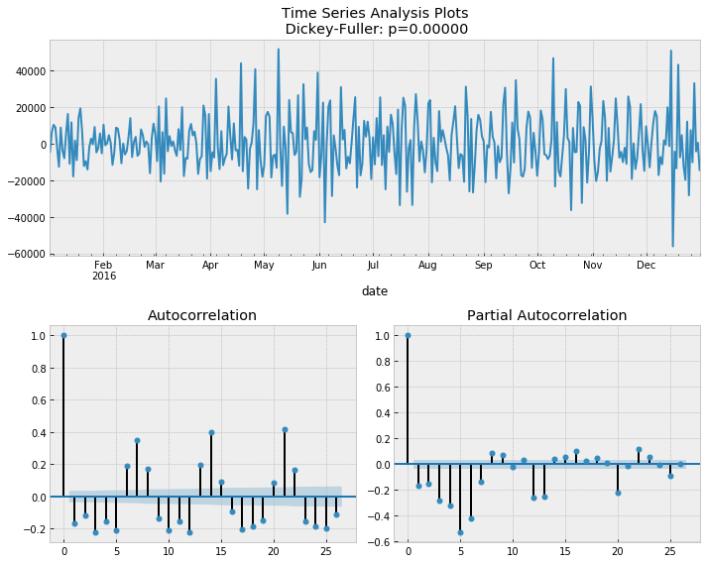

### Model Determination:

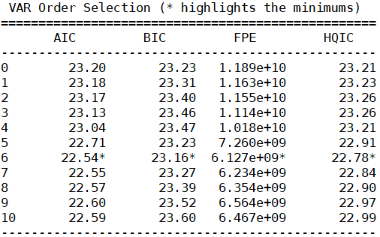

### Model Estimation:

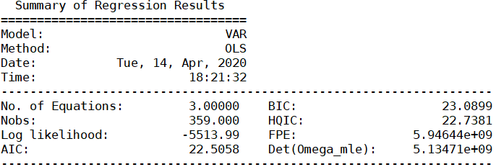

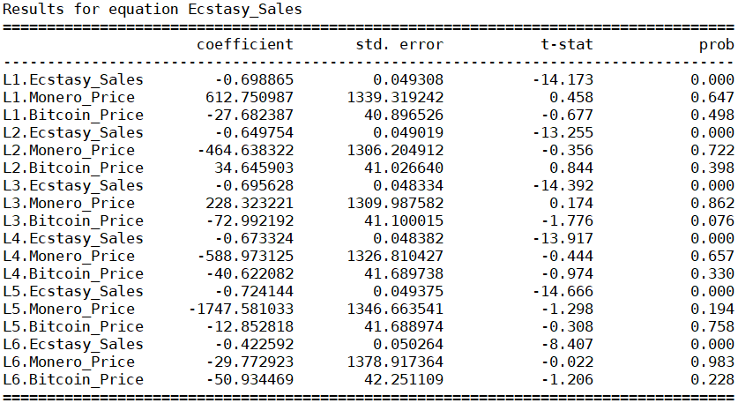

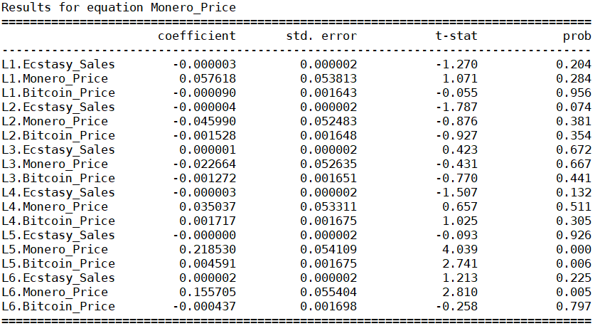

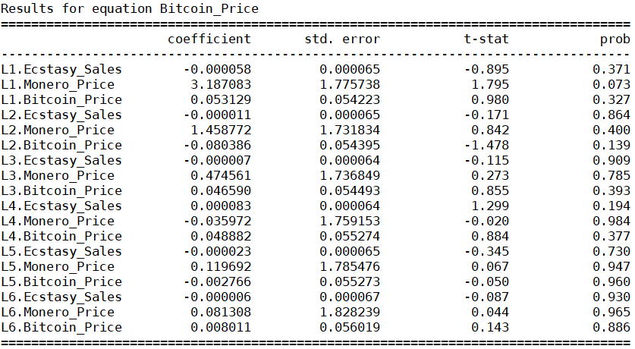

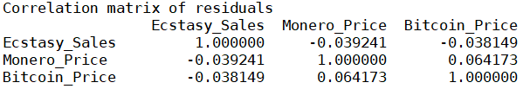

### Model Diagnostics:

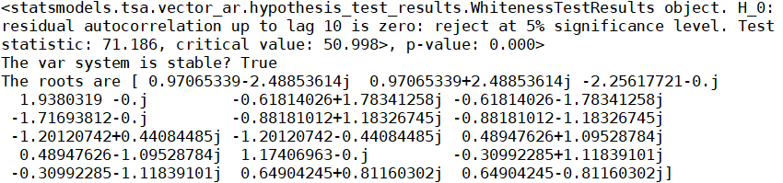

### Structural Analysis:

#### Granger Causality

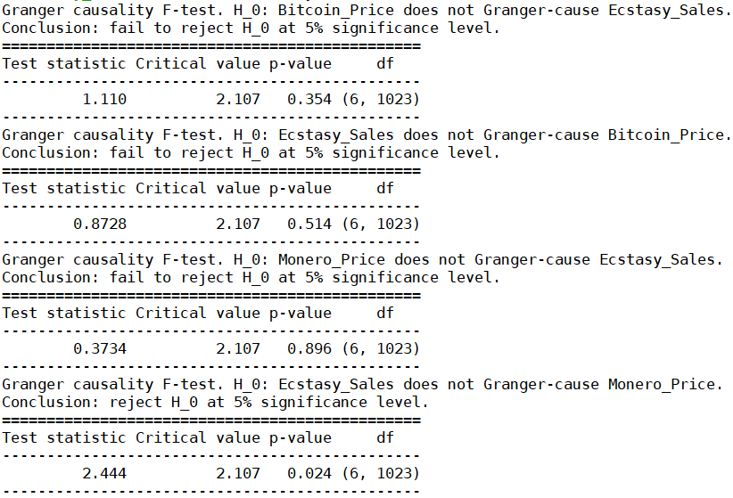

From the p-values of the Granger Causality tests, we can see that Ecstasy_Sales granger-causes Monero_Price.

*$Instant*

*H0: No instantaneous causality between: Monero_Price and ecastasy_Sales*

*data: VAR object bv12.est*

*Chi-squared = 0.57866, df = 1, p-value = 0.4468*

*$Instant*

*H0: No instantaneous causality between: ecstasy_Sales and Monero_Price*

*data: VAR object bv12.est*

*Chi-squared = 0.57866, df = 1, p-value = 0.4468*

*$Instant*

*H0: No instantaneous causality between: ecstasy_Sales and Bitcoin_Price*

*data: VAR object bv23.est*

*Chi-squared = 0.47829, df = 1, p-value = 0.4892*

*$Instant*

*H0: No instantaneous causality between: Bitcoin_Price and ecstasy_Sales*

*data: VAR object bv23.est*

*Chi-squared = 0.47829, df = 1, p-value = 0.4892*

We observe that the null hypothesis that there are no contemporaneous relations failed to be rejected for all variables.

#### Impulse Response Analysis

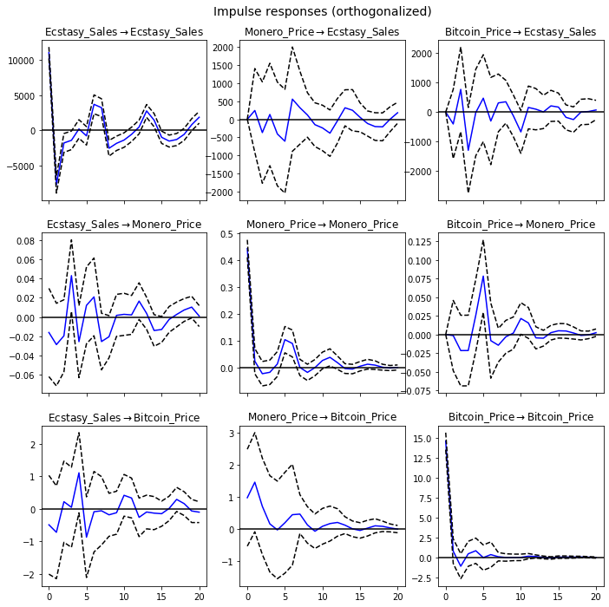

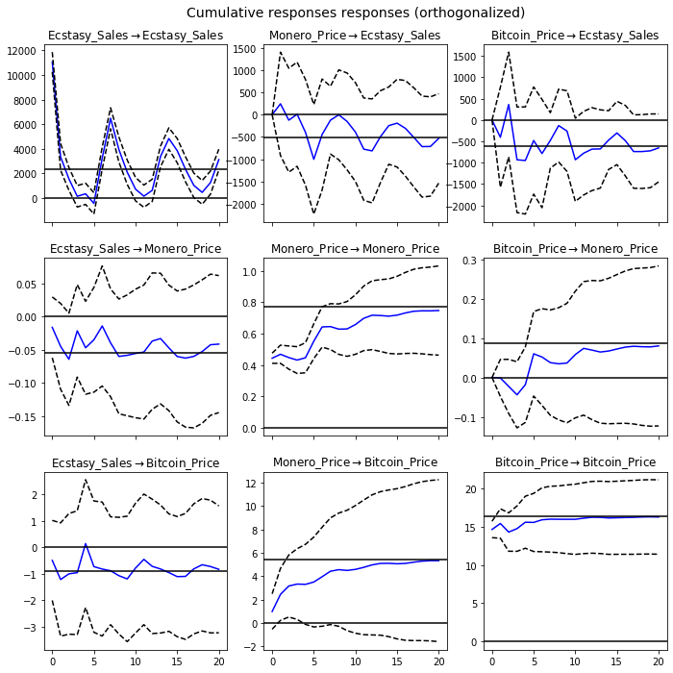

#### Forecast Error Variance Decomposition (FEVD)

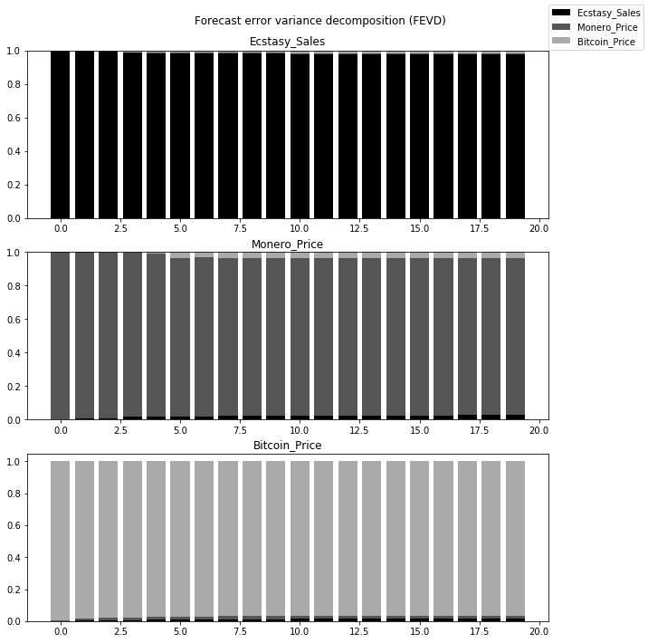

# 

## WEEKLY

### Check for stationarity and making the time series stationary (Weekly):

Drugs

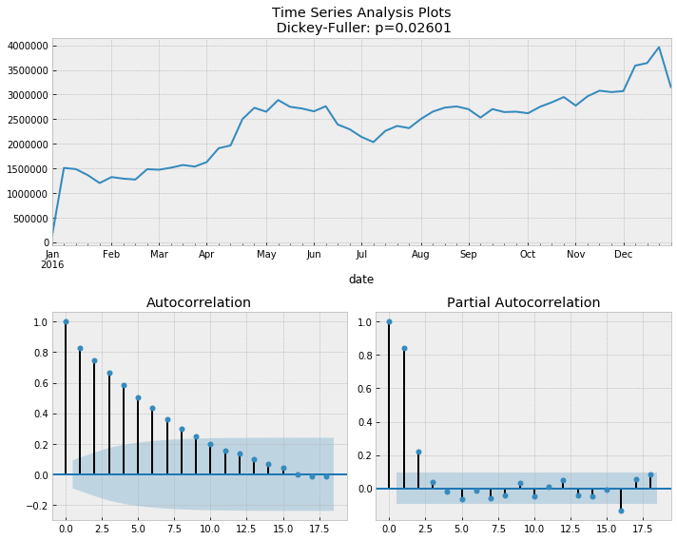

Bitcoin

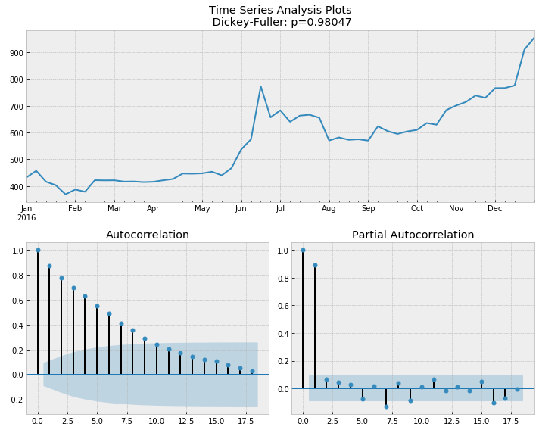

Monero

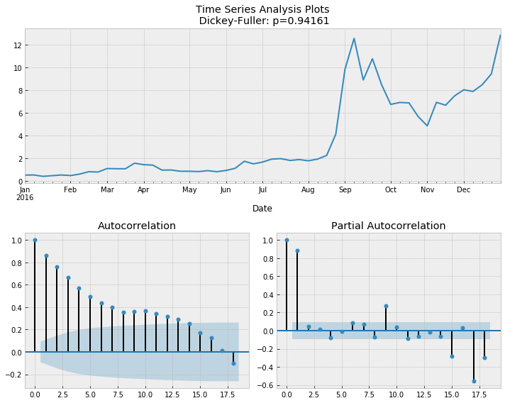

Bitcoin Differenced

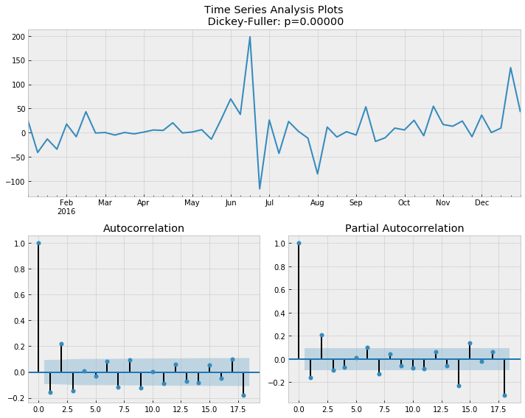

Monero Differenced

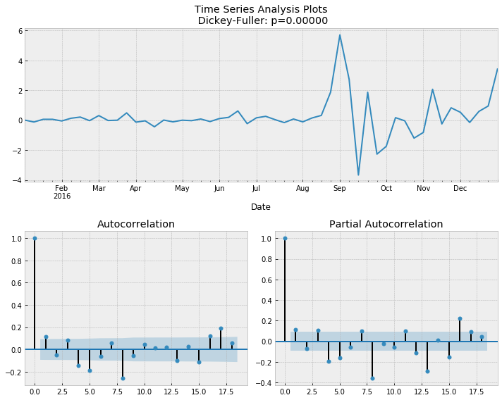

### Total Drugs vs Bitcoin vs Monero (Weekly)

### Model Determination:

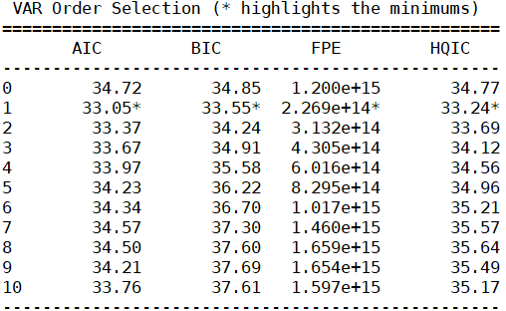

### Model Estimation:

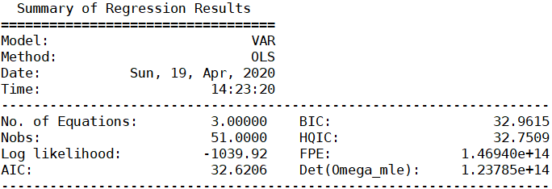

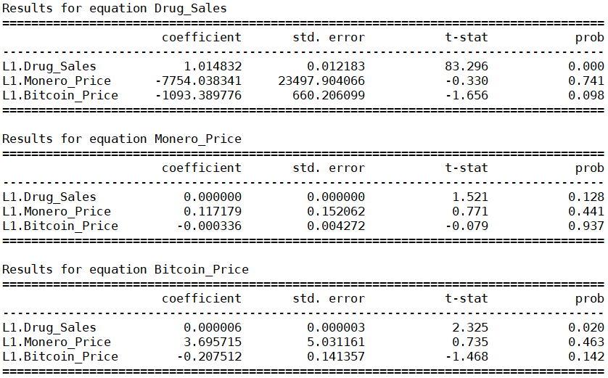

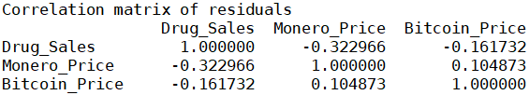

### Model Diagnostics:

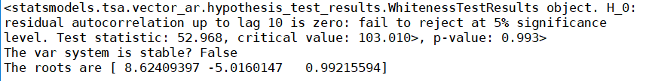

### Structural Analysis:

#### Granger Causality

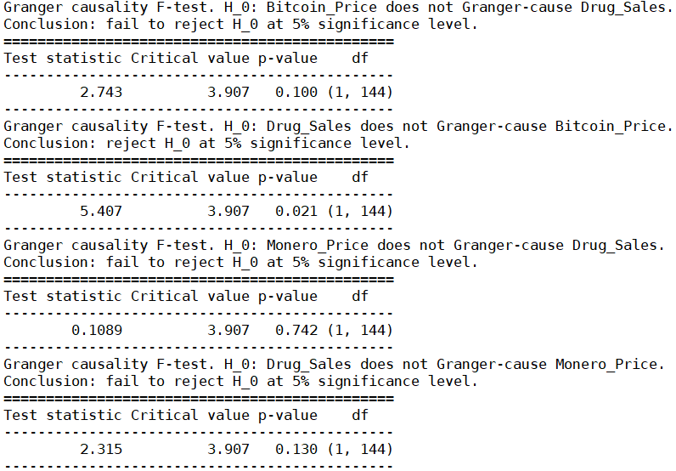

From the p-values of the Granger Causality tests, we can see that Drug_sales granger-causes Bitcoin_Price

*$Instant*

*H0: No instantaneous causality between: Monero_Price and Drug_Sales*

*data: VAR object bv12.est*

*Chi-squared = 3.9085, df = 1, p-value = 0.04804*

*$Instant*

*H0: No instantaneous causality between: Drug_Sales and Monero_Price*

*data: VAR object bv12.est*

*Chi-squared = 3.9085, df = 1, p-value = 0.04804*

*$Instant*

*H0: No instantaneous causality between: Drug_Sales and Bitcoin_Price*

*data: VAR object bv23.est*

*Chi-squared = 0.80006, df = 1, p-value = 0.3711*

*$Instant*

*H0: No instantaneous causality between: Bitcoin_Price and Drug_Sales*

*data: VAR object bv23.est*

*Chi-squared = 0.80006, df = 1, p-value = 0.3711*

We observe that the null hypothesis that there are no contemporaneous relations is rejected between drug sales and moenro prices

#### Impulse Response Analysis

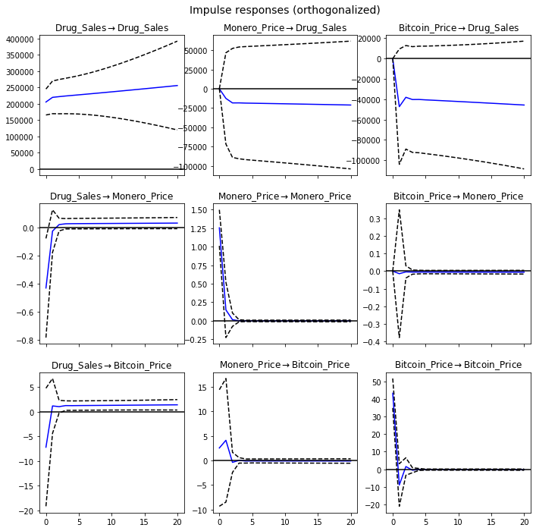

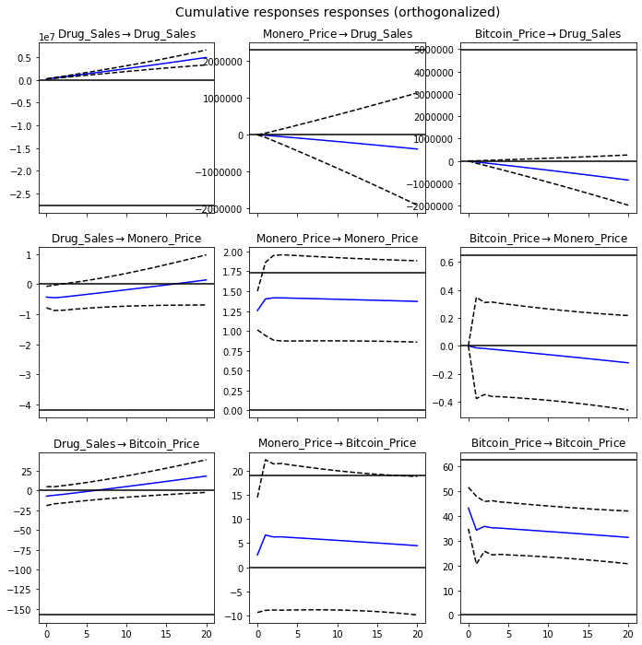

#### Forecast Error Variance Decomposition (FEVD)

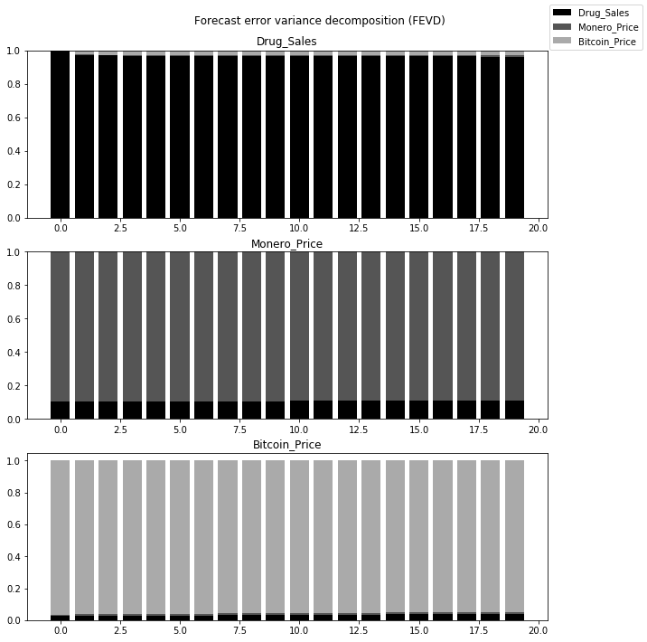

### Cannabis vs Bitcoin vs Monero (Weekly)

Cannabis

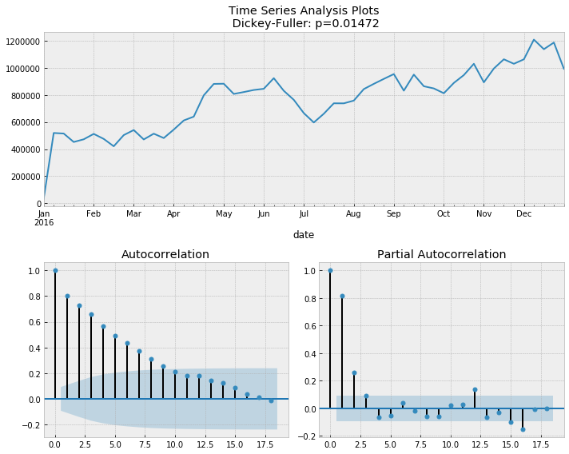

### Model Determination:

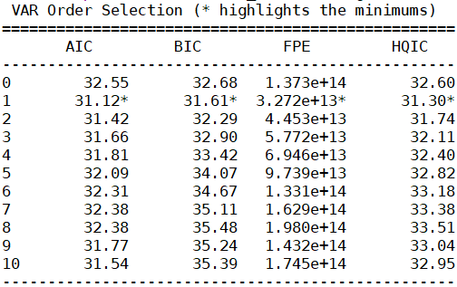

### Model Estimation:

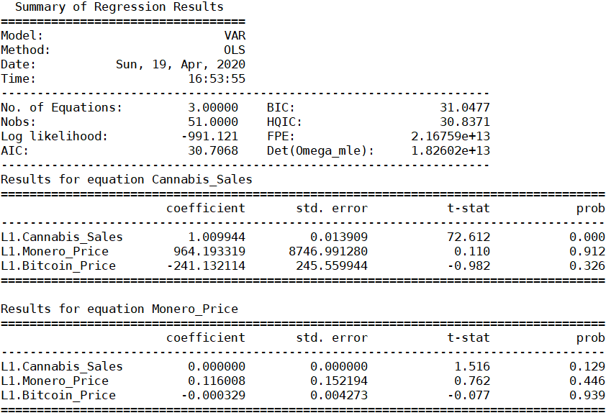

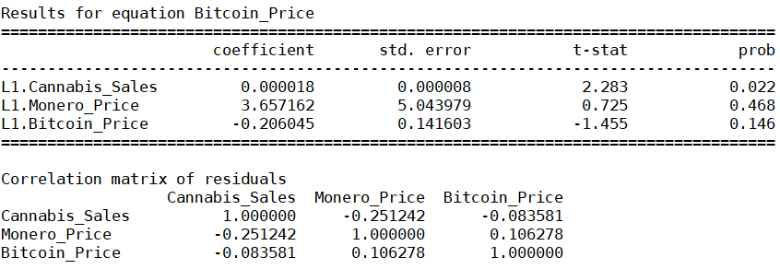

### Model Diagnostics:

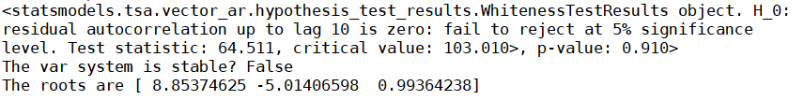

### Structural Analysis:

#### Granger Causality bc 0.328, cb 0.024, mc 0.912, cm 0.132

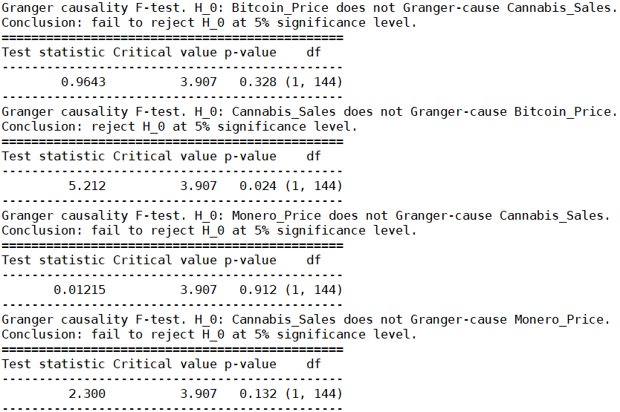

From the p-values of the Granger Causality tests, we can see that Cannabis_Sales granger-causes Bitcoin_Price.

*$Instant*

*H0: No instantaneous causality between: Monero_Price and cannabis_Sales*

*data: VAR object bv12.est*

*Chi-squared = 2.3245, df = 1, p-value = 0.1273*

*$Instant*

*H0: No instantaneous causality between: cannabis_Sales and Monero_Price*

*data: VAR object bv12.est*

*Chi-squared = 2.3245, df = 1, p-value = 0.1273*

*$Instant*

*H0: No instantaneous causality between: cannabis_Sales and Bitcoin_Price*

*data: VAR object bv23.est*

*Chi-squared = 0.042882, df = 1, p-value = 0.8359*

*$Instant*

*H0: No instantaneous causality between: Bitcoin_Price and cannabis_Sales*

*data: VAR object bv23.est*

*Chi-squared = 0.042882, df = 1, p-value = 0.8359*

We observe that the null hypothesis that there are no contemporaneous relations failed to be rejected for all variables

#### Impulse Response Analysis

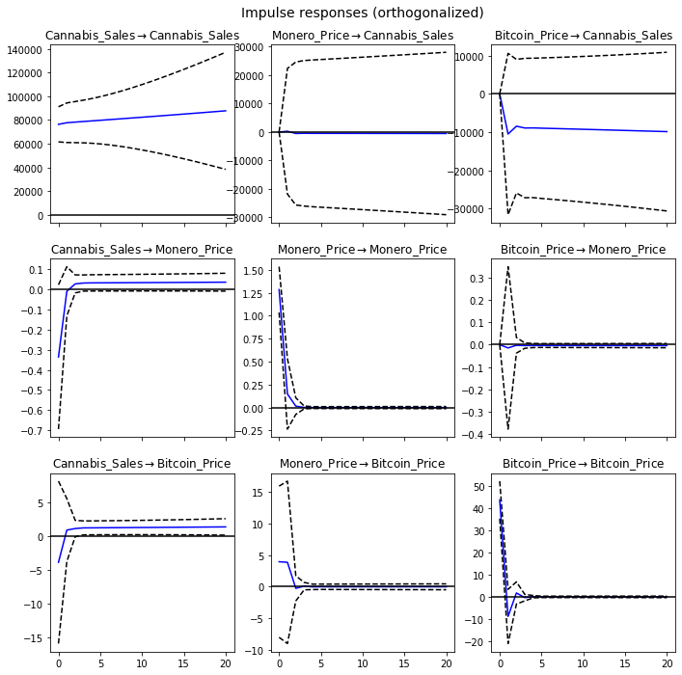

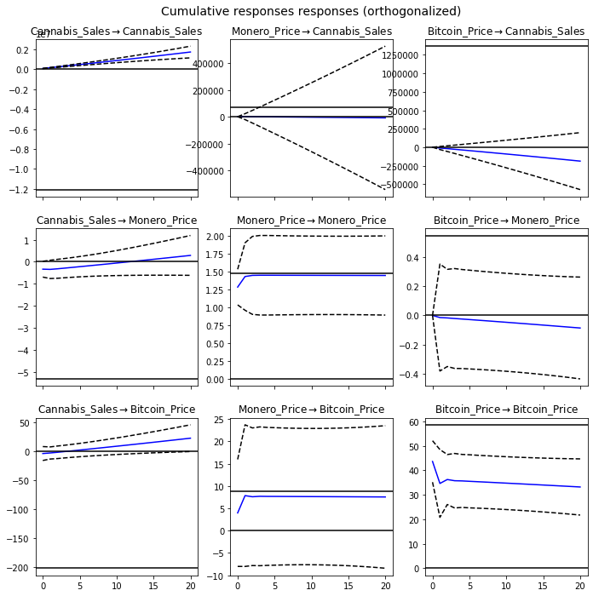

#### Forecast Error Variance Decomposition (FEVD)

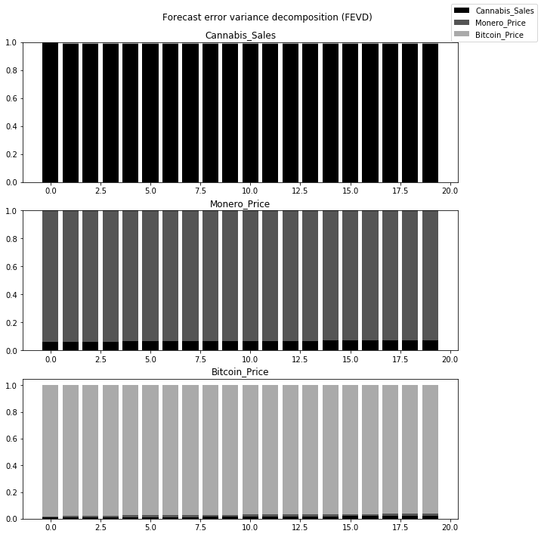

### Stimulants vs Bitcoin vs Monero (Weekly)

Stimulants

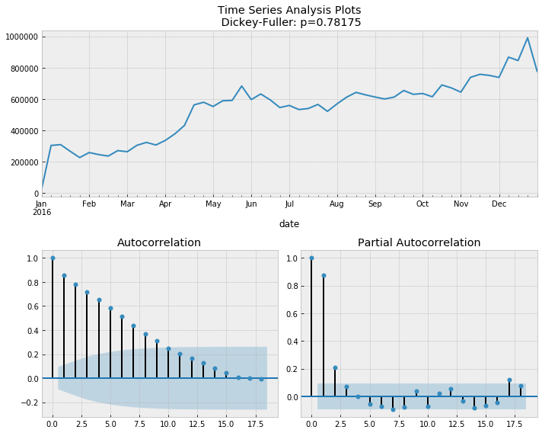

Stimulants differenced

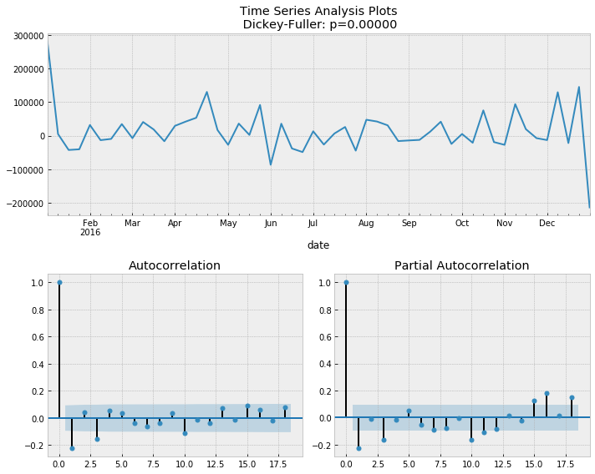

### Model Determination:

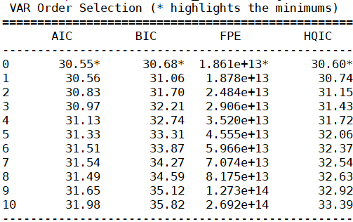

### Model Estimation:

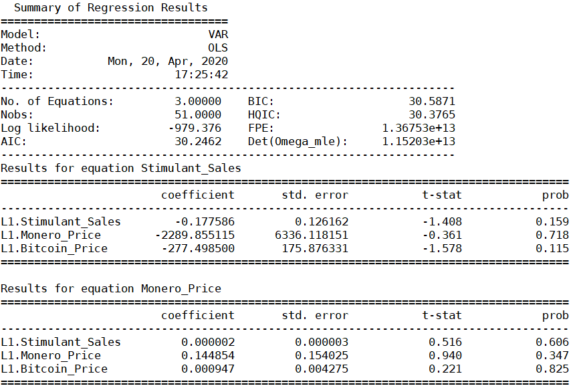

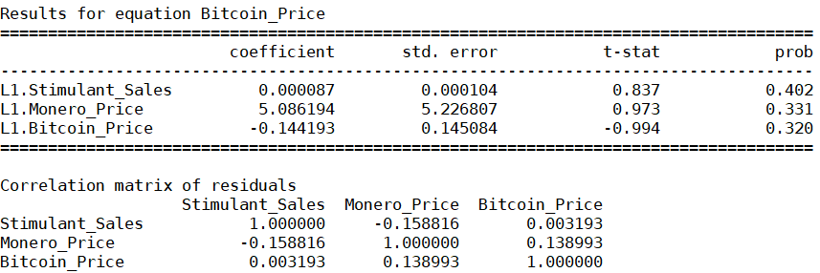

### Model Diagnostics:

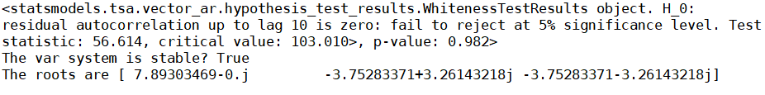

### Structural Analysis:

#### Granger Causality

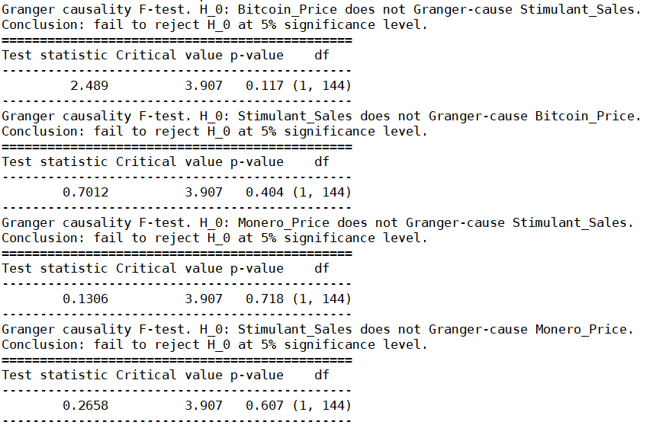

*$Instant*

*H0: No instantaneous causality between: Monero_Price and stimulants_Sales*

*data: VAR object bv12.est*

*Chi-squared = 1.3111, df = 1, p-value = 0.2522*

*$Instant*

*H0: No instantaneous causality between: stimulants_Sales and Monero_Price*

*data: VAR object bv12.est*

*Chi-squared = 1.3111, df = 1, p-value = 0.2522*

*$Instant*

*H0: No instantaneous causality between: stimulants_Sales and Bitcoin_Price*

*data: VAR object bv23.est*

*Chi-squared = 0.01359, df = 1, p-value = 0.9072*

*$Instant*

*H0: No instantaneous causality between: Bitcoin_Price and stimulants_Sales*

*data: VAR object bv23.est*

*Chi-squared = 0.01359, df = 1, p-value = 0.9072*

We observe that the null hypothesis that there are no contemporaneous relations failed to be rejected for all variables

#### Impulse Response Analysis

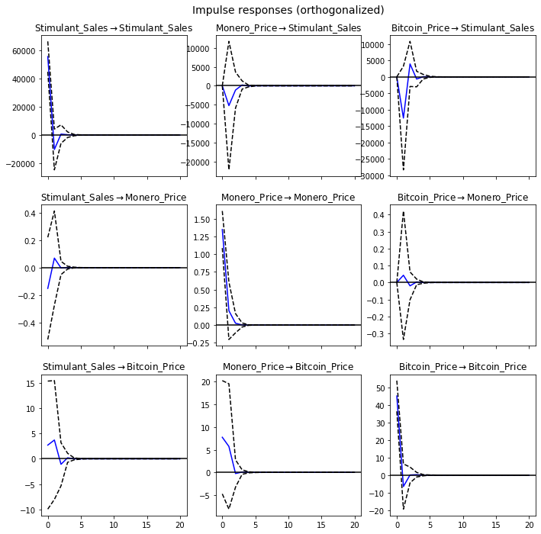

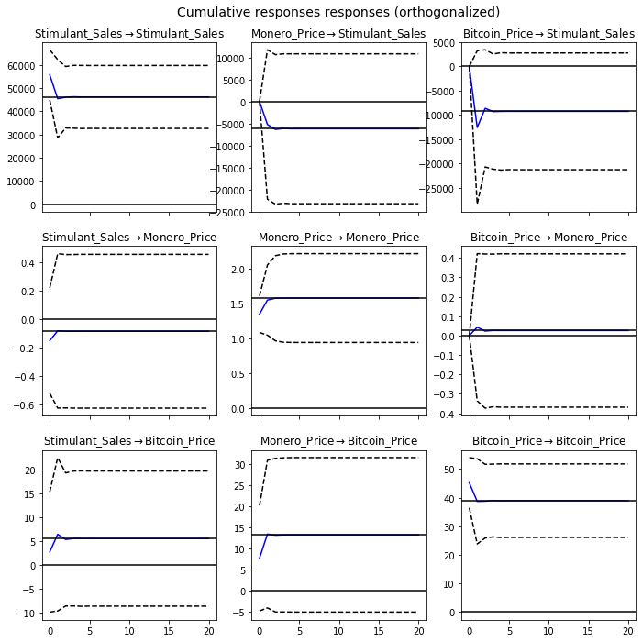

#### Forecast Error Variance Decomposition (FEVD)

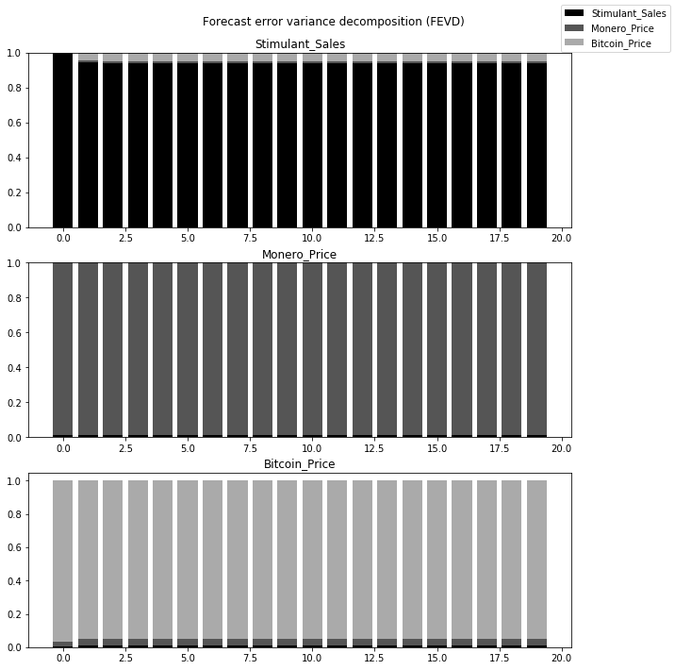

### Ecstasy vs Bitcoin vs Monero (Weekly)

Ecstasy

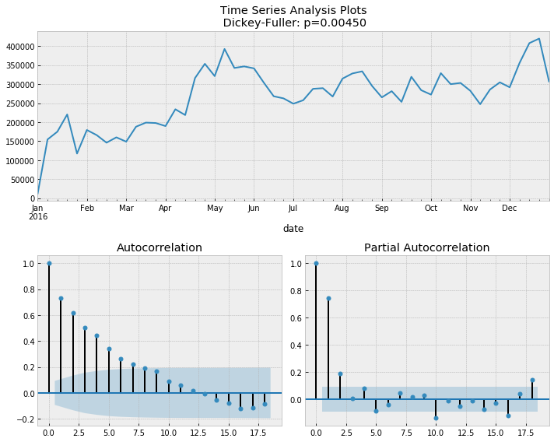

### Model Determination:

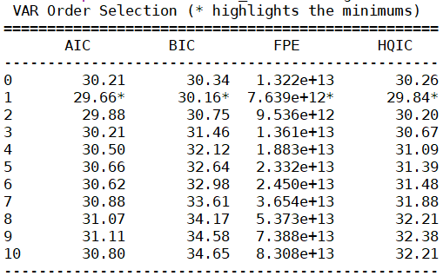

### Model Estimation:

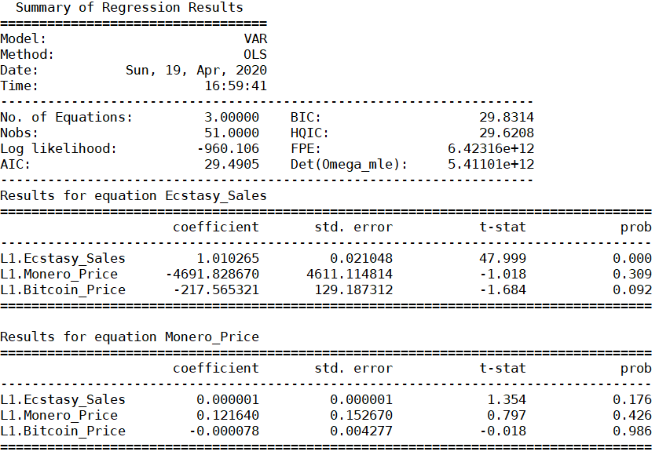

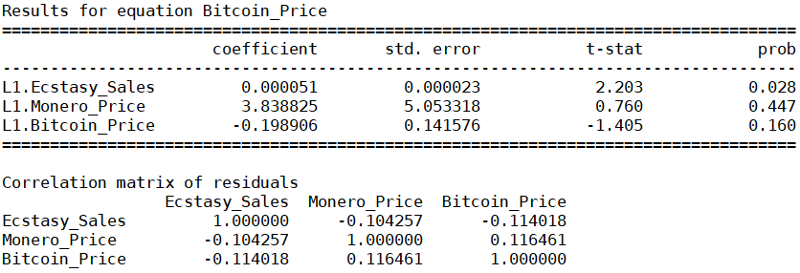

### Model Diagnostics:

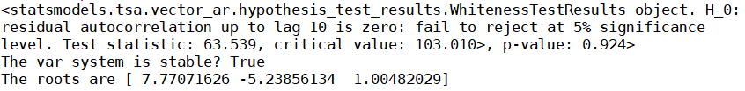

### Structural Analysis: be 0.094, eb 0.029, me 0.311, em 0.178

#### Granger Causality

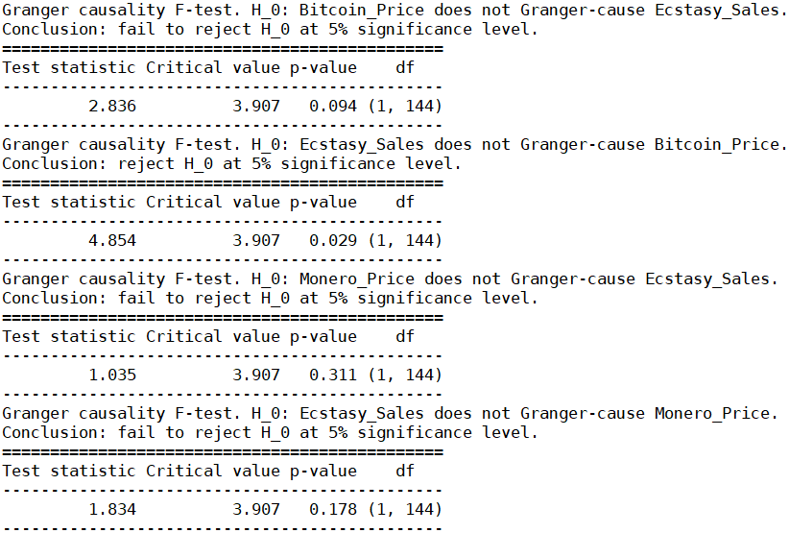

From the p-values of the Granger Causality tests, we can see that Ecstasy_Sales granger-causes Bitcoin_Price.

*$Instant*

*H0: No instantaneous causality between: Monero_Price and ecstasy_Sales*

*data: VAR object bv12.est*

*Chi-squared = 1.2281, df = 1, p-value = 0.2678*

*$Instant*

*H0: No instantaneous causality between: ecstasy_Sales and Monero_Price*

*data: VAR object bv12.est*

*Chi-squared = 1.2281, df = 1, p-value = 0.2678*

*$Instant*

*H0: No instantaneous causality between: ecstasy_Sales and Bitcoin_Price*

*data: VAR object bv23.est*

*Chi-squared = 1.7169, df = 1, p-value = 0.1901*

*$Instant*

*H0: No instantaneous causality between: Bitcoin_Price and ecstasy_Sales*

*data: VAR object bv23.est*

*Chi-squared = 1.7169, df = 1, p-value = 0.1901*

We observe that the null hypothesis that there are no contemporaneous relations failed to be rejected for all variables

#### Impulse Response Analysis

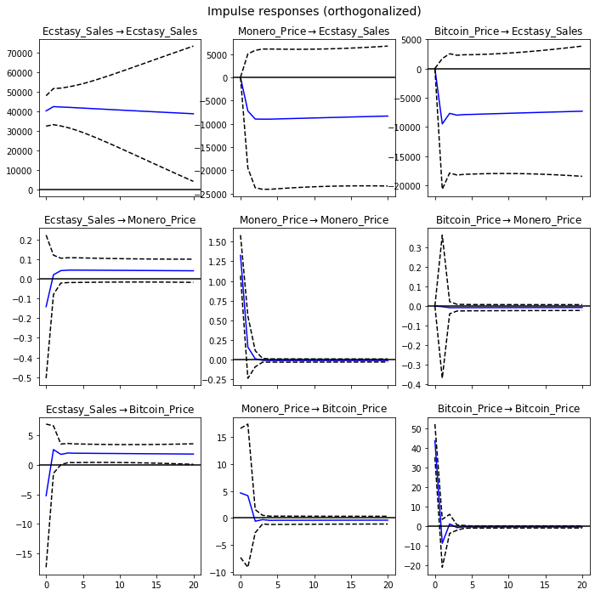

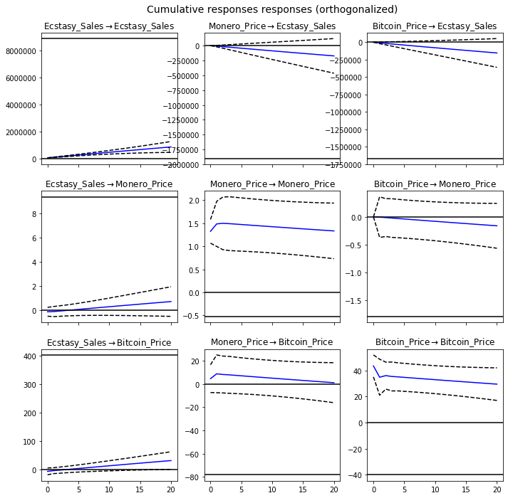

#### Forecast Error Variance Decomposition (FEVD)

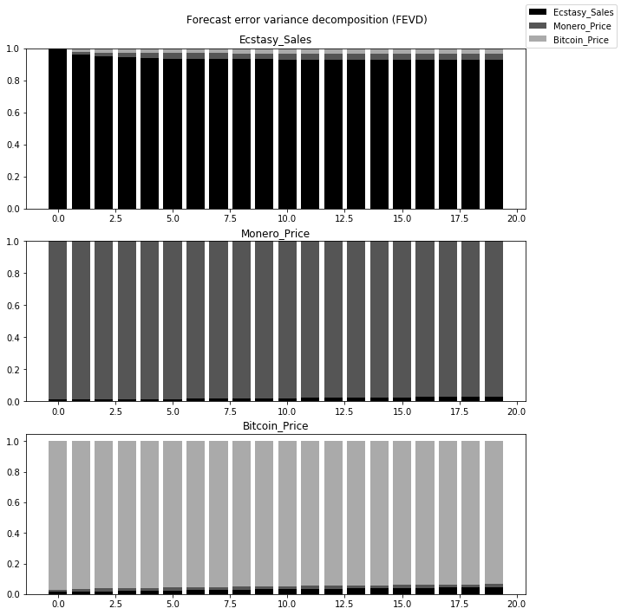

## BIWEEKLY

### Check for stationarity and making the time series stationary (Biweekly):

Drug

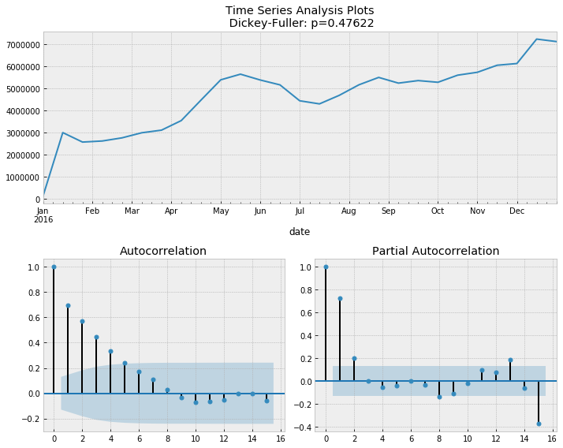

Bitcoin

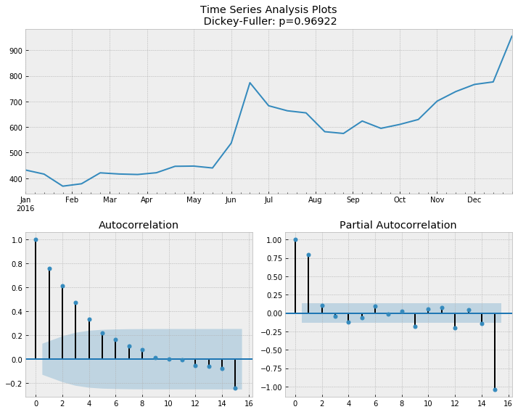

Monero

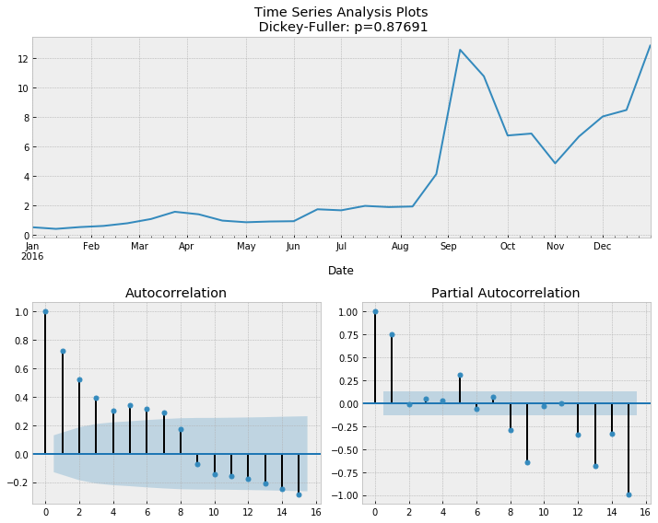

Drug Differenced

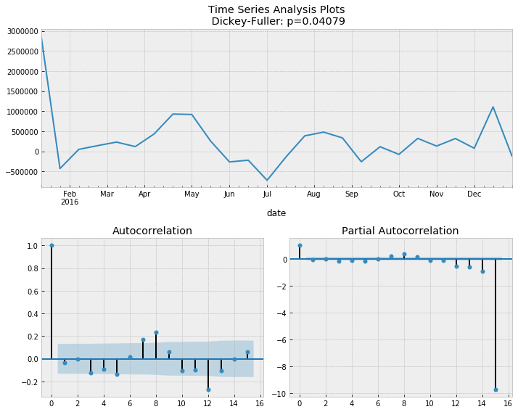

Bitcoin Differenced

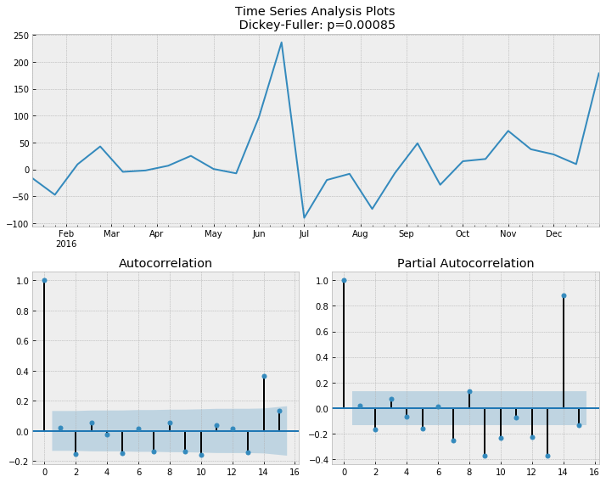

Monero Differenced

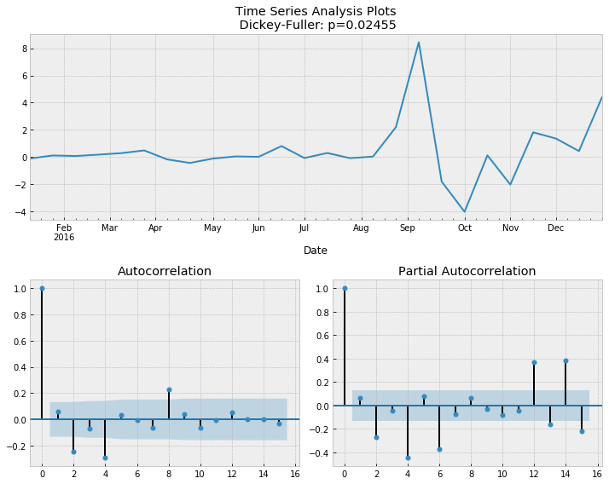

### Total Drugs vs Bitcoin vs Monero (Biweekly)

### Model Determination:

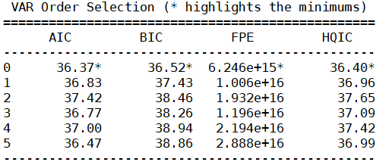

### Model Estimation:

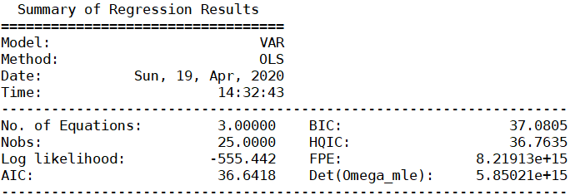

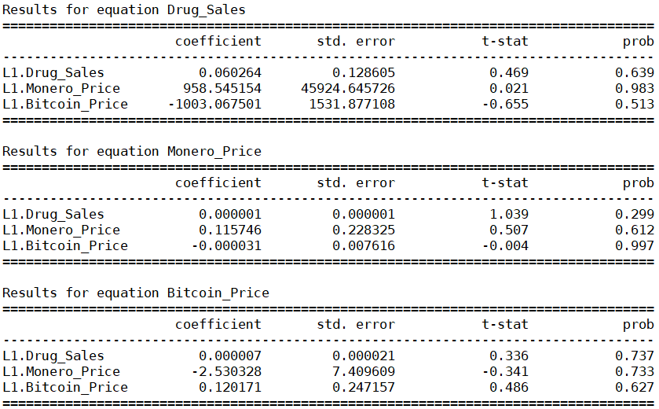

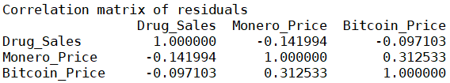

### Model Diagnostics:

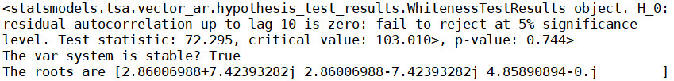

### Structural Analysis:

#### Granger Causality

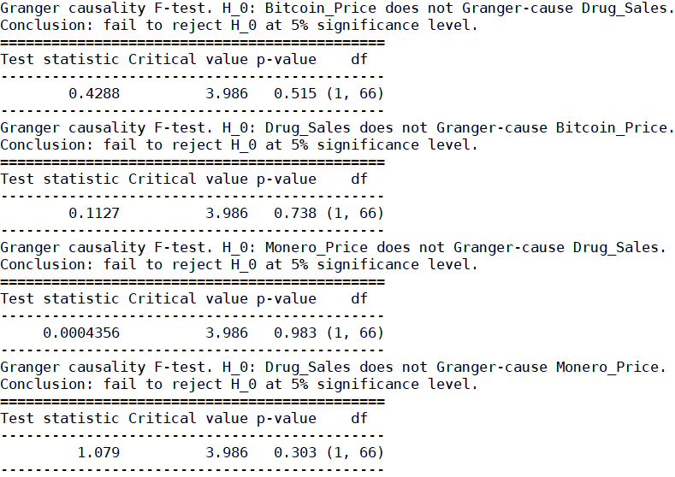

*$Instant*

*H0: No instantaneous causality between: Monero_Price and Drug_Sales*

*data: VAR object bv12.est*

*Chi-squared = 0.53029, df = 1, p-value = 0.4665*

*$Instant*

*H0: No instantaneous causality between: Drug_Sales and Monero_Price*

*data: VAR object bv12.est*

*Chi-squared = 0.53029, df = 1, p-value = 0.4665*

*$Instant*

*H0: No instantaneous causality between: Drug_Sales and Bitcoin_Price*

*data: VAR object bv23.est*

*Chi-squared = 0.37931, df = 1, p-value = 0.538*

*$Instant*

*H0: No instantaneous causality between: Bitcoin_Price and Drug_Sales*

*data: VAR object bv23.est*

*Chi-squared = 0.37931, df = 1, p-value = 0.538*

We observe that the null hypothesis that there are no contemporaneous relations failed be rejected for all variables

#### Impulse Response Analysis

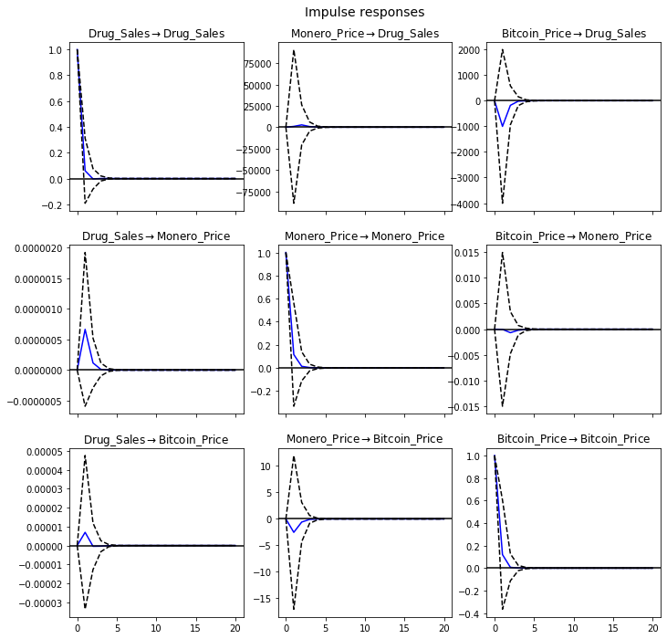

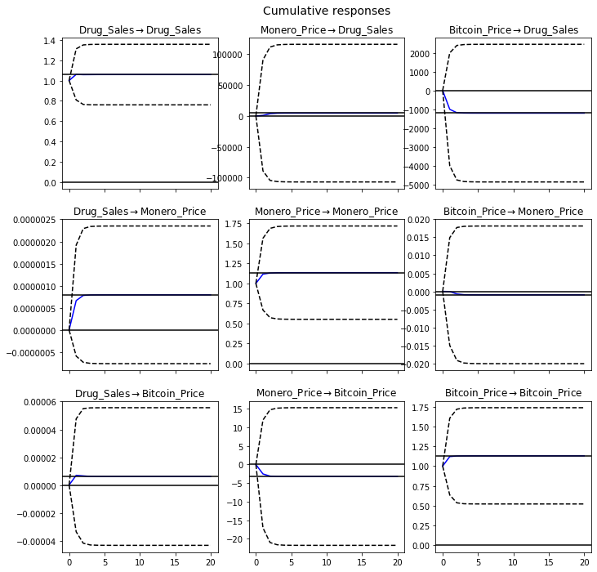

#### Forecast Error Variance Decomposition (FEVD)

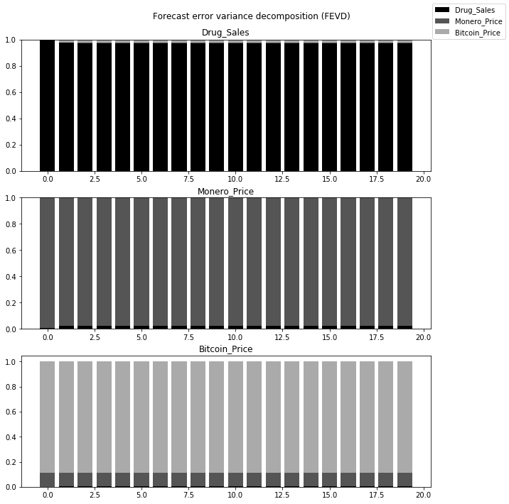

### Cannabis vs Bitcoin vs Monero (Biweekly)

Cannabis

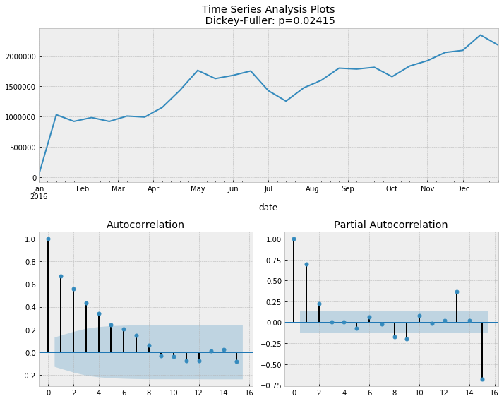

### Model Determination:

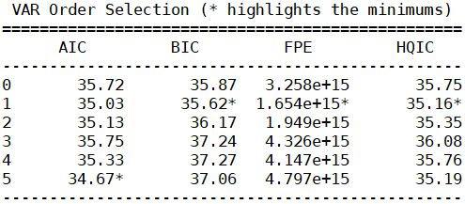

### Model Estimation:

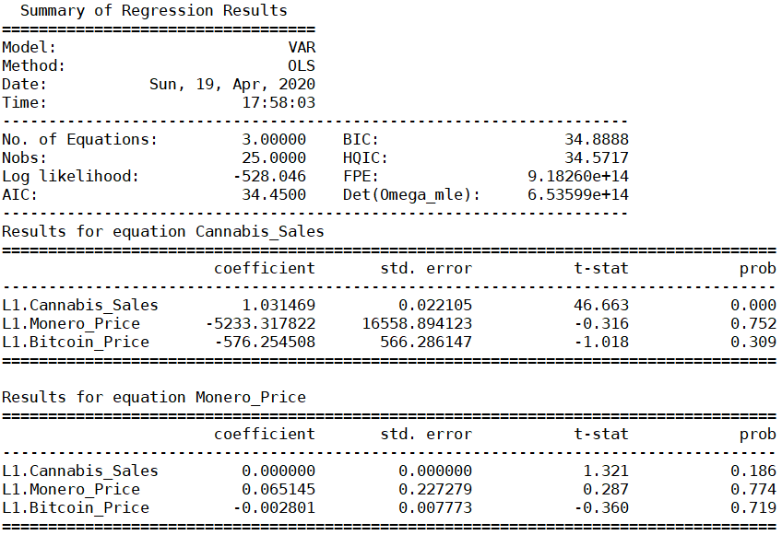

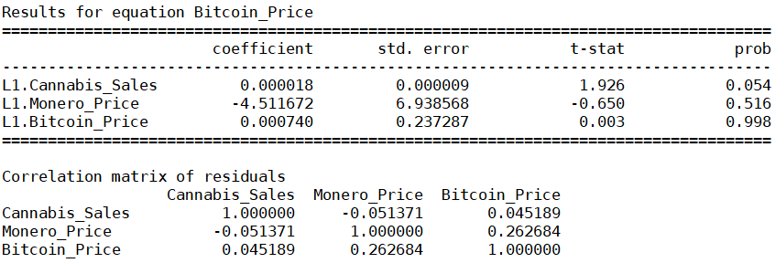

*$Instant*

*H0: No instantaneous causality between: Monero_Price and cannabis_Sales*

*data: VAR object bv12.est*

*Chi-squared = 0.00013018, df = 1, p-value = 0.9909*

*$Instant*

*H0: No instantaneous causality between: cannabis_Sales and Monero_Price*

*data: VAR object bv12.est*

*Chi-squared = 0.00013018, df = 1, p-value = 0.9909*

*$Instant*

*H0: No instantaneous causality between: cannabis_Sales and Bitcoin_Price*

*data: VAR object bv23.est*

*Chi-squared = 0.28194, df = 1, p-value = 0.5954*

*$Instant*

*H0: No instantaneous causality between: Bitcoin_Price and cannabis_Sales*

*data: VAR object bv23.est*

*Chi-squared = 0.28194, df = 1, p-value = 0.5954*

We observe that the null hypothesis that there are no contemporaneous relations failed to be rejected between all variables

### Model Diagnostics:

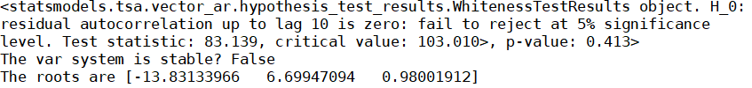

### Structural Analysis:

#### Granger Causality

#### Impulse Response Analysis

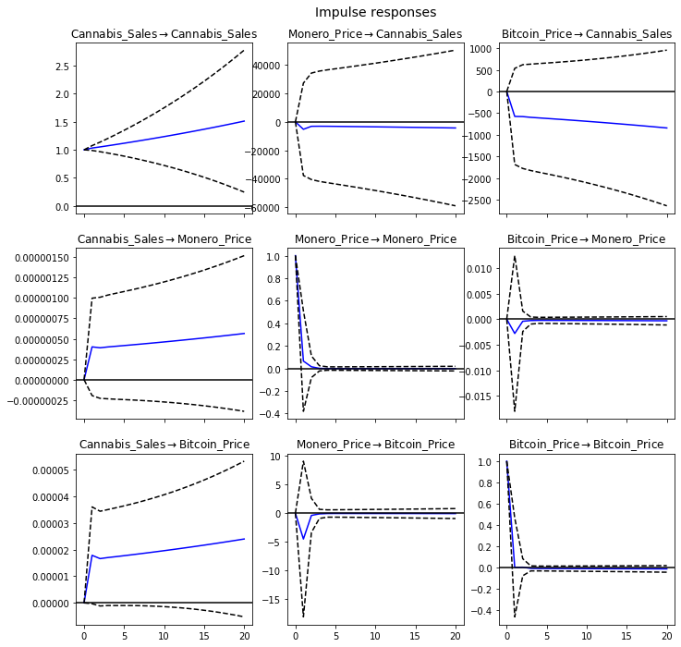

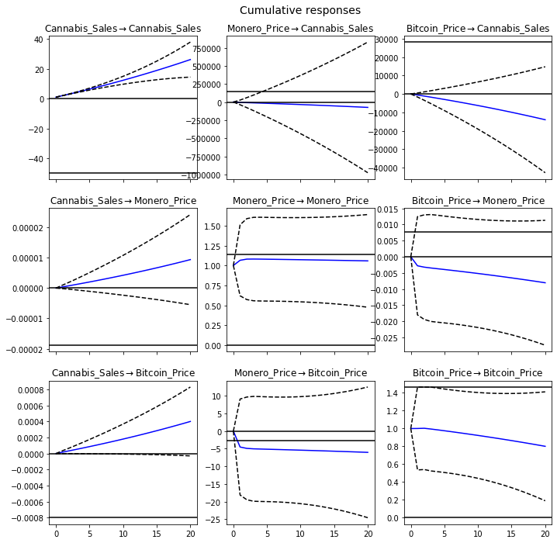

#### Forecast Error Variance Decomposition (FEVD)

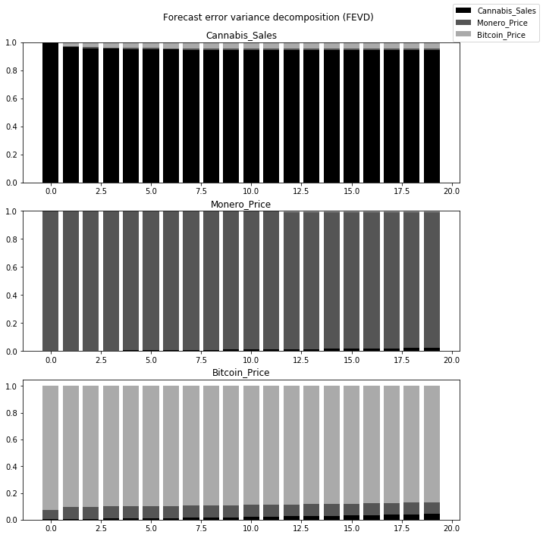

### Stimulants vs Bitcoin vs Monero (Biweekly)

Stimulants

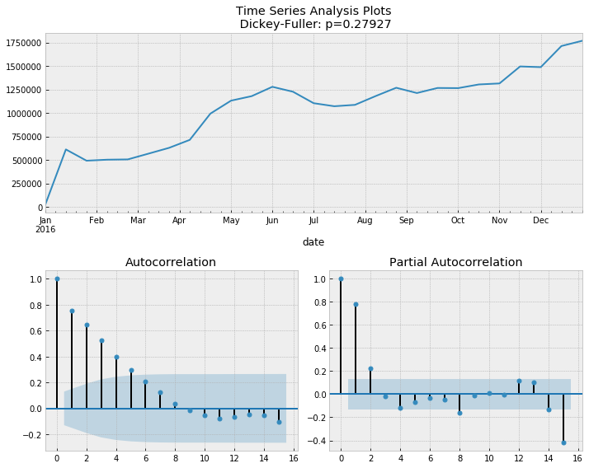

Stimulants differenced

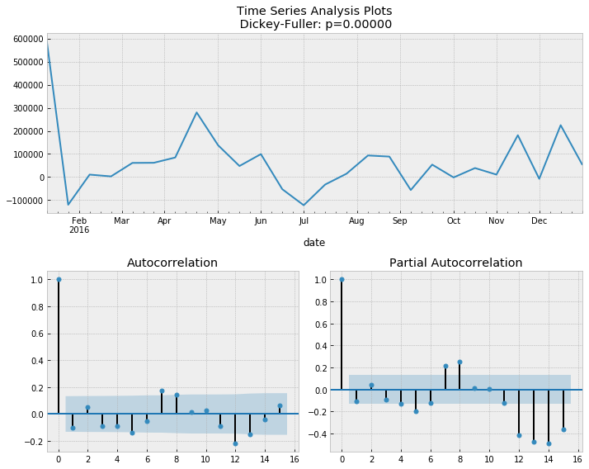

### Model Determination:

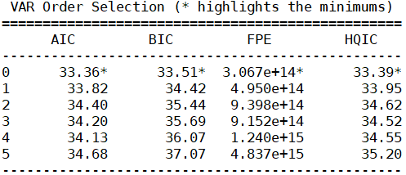

### Model Estimation:

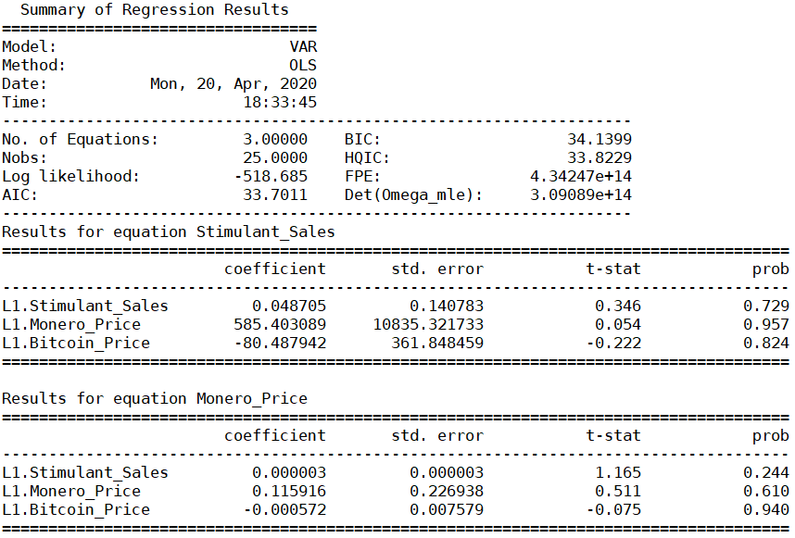

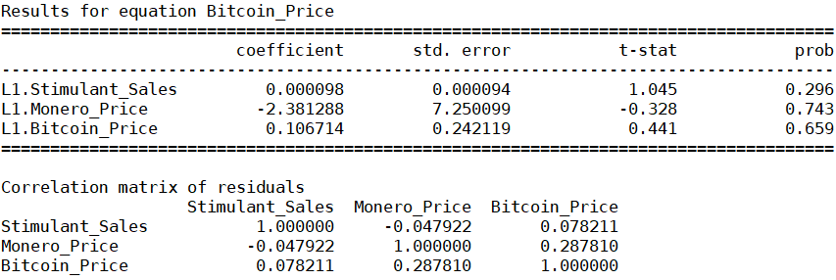

### Model Diagnostics:

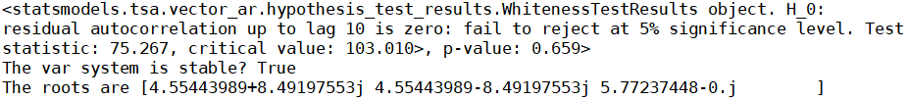

### Structural Analysis:

#### Granger Causality

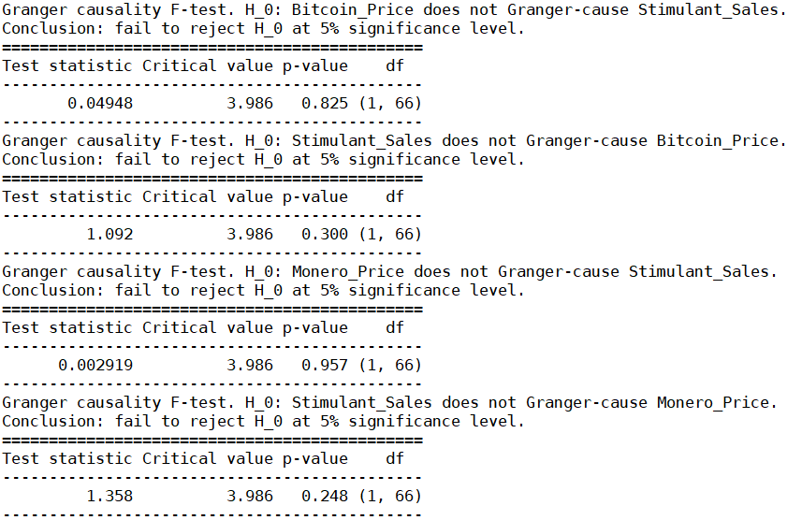

*$Instant*

*H0: No instantaneous causality between: Monero_Price and stimulants_Sales*

*data: VAR object bv12.est*

*Chi-squared = 0.088257, df = 1, p-value = 0.7664*

*$Instant*

*H0: No instantaneous causality between: stimulants_Sales and Monero_Price*

*data: VAR object bv12.est*

*Chi-squared = 0.088257, df = 1, p-value = 0.7664*

*$Instant*

*H0: No instantaneous causality between: stimulants_Sales and Bitcoin_Price*

*data: VAR object bv23.est*

*Chi-squared = 0.076755, df = 1, p-value = 0.7817*

*$Instant*

*H0: No instantaneous causality between: Bitcoin_Price and stimulants_Sales*

*data: VAR object bv23.est*

*Chi-squared = 0.076755, df = 1, p-value = 0.7817*

We observe that the null hypothesis that there are no contemporaneous relations failed to be rejected between variables

#### Impulse Response Analysis

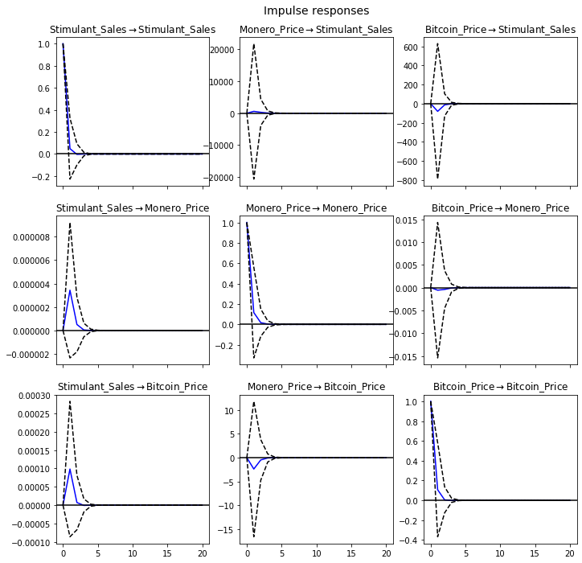

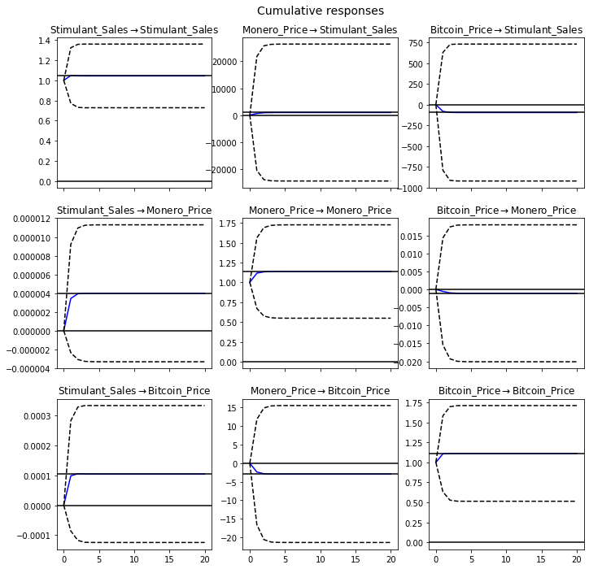

#### Forecast Error Variance Decomposition (FEVD)

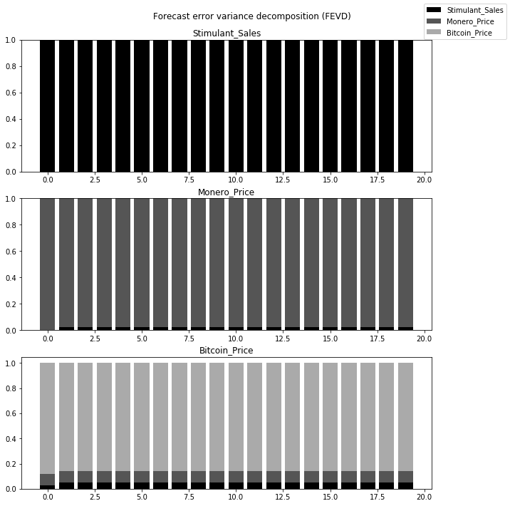

### Ecstasy vs Bitcoin vs Monero (Biweekly)

Ecstasy

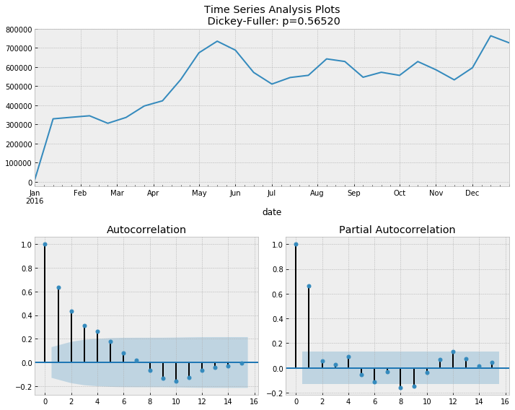

Ecstasy differenced

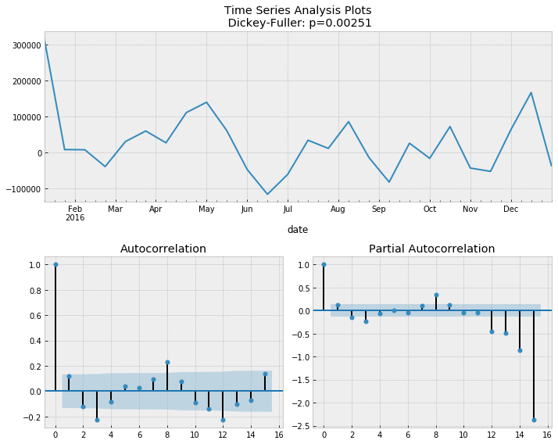

### Model Determination:

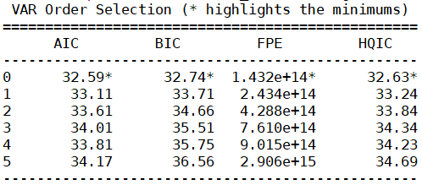

### Model Estimation:

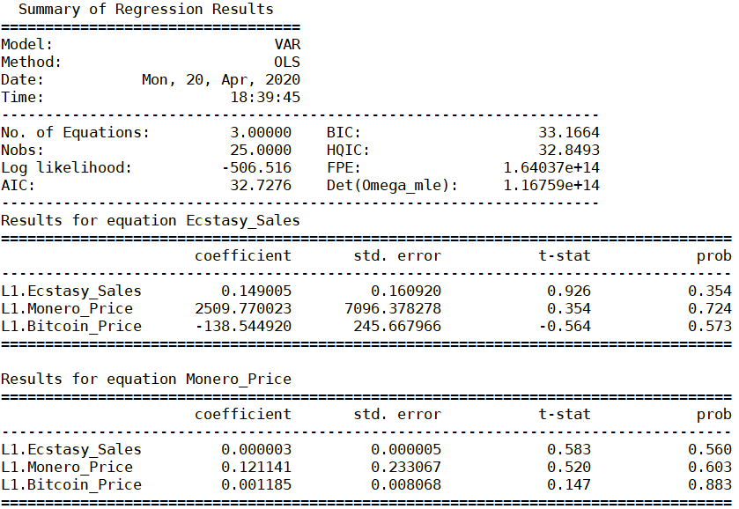

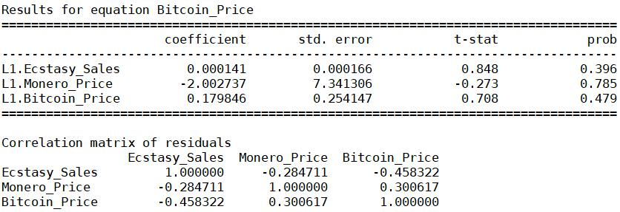

### Model Diagnostics:

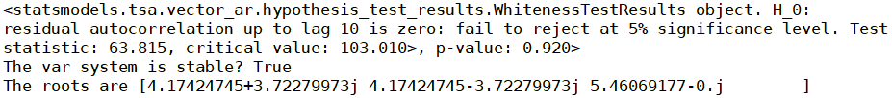

### Structural Analysis:

#### Granger Causality

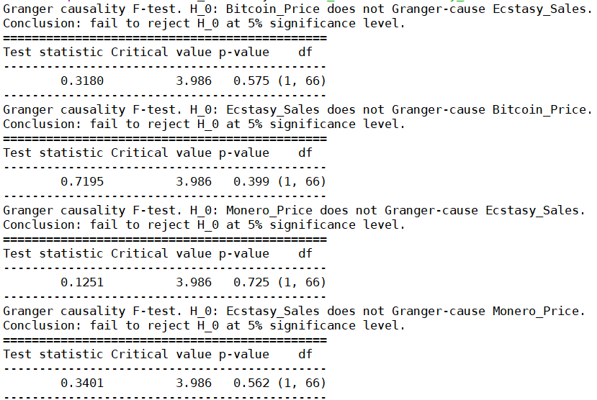

*$Instant*

*H0: No instantaneous causality between: Monero_Price and ecstasy_Sales*

*data: VAR object bv12.est*

*Chi-squared = 1.8893, df = 1, p-value = 0.1693*

*$Instant*

*H0: No instantaneous causality between: ecstasy_Sales and Monero_Price*

*data: VAR object bv12.est*

*Chi-squared = 1.8893, df = 1, p-value = 0.1693*

*$Instant*

*H0: No instantaneous causality between: ecstasy_Sales and Bitcoin_Price*

*data: VAR object bv23.est*

*Chi-squared = 4.671, df = 1, p-value = 0.03068*

*$Instant*

*H0: No instantaneous causality between: Bitcoin_Price and ecstasy_Sales*

*data: VAR object bv23.est*

*Chi-squared = 4.671, df = 1, p-value = 0.03068*

We observe that the null hypothesis that there are no contemporaneous relations is rejected between Bitcoin_Price and ecstasy_Sales

#### Impulse Response Analysis

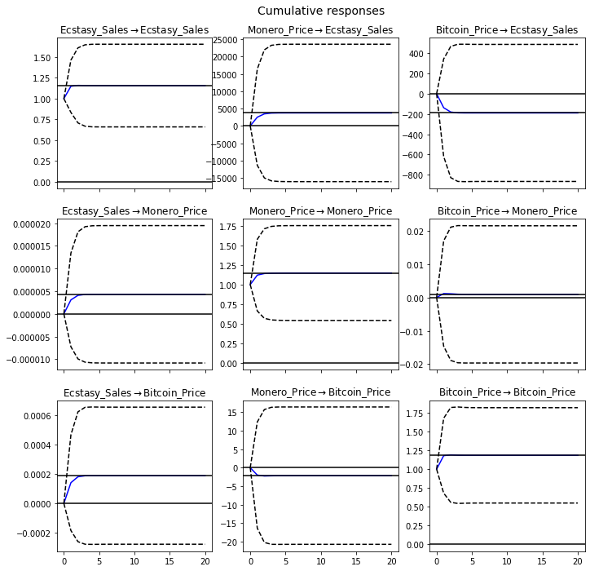

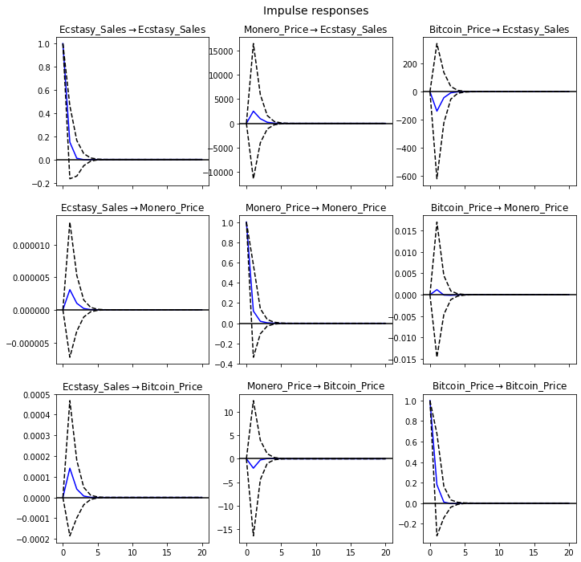

#### Forecast Error Variance Decomposition (FEVD)

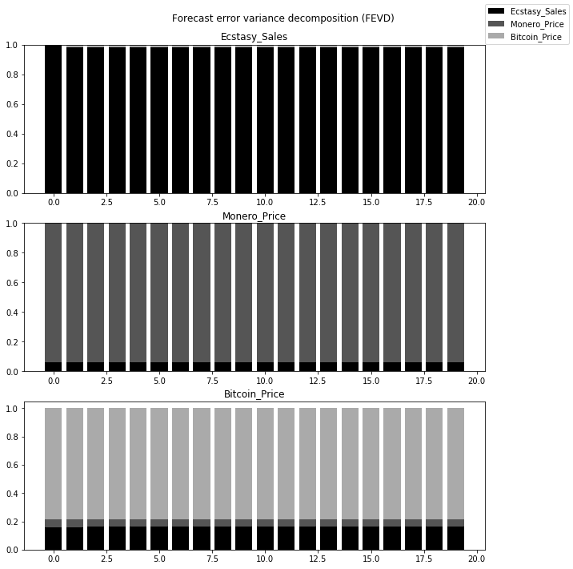

# 

# 8 References

[https://www.investopedia.com/terms/d/dark-web.as](https://www.investopedia.com/terms/d/dark-web.asp)

<https://thecontrol.co/meet-the-best-performing-digital-currency-of-2016-monero-e6010768e54a>

<https://www.rand.org/news/press/2016/08/08.html>

<https://www.investopedia.com/tech/why-bitcoin-price-predictions-are-unreliable/>

<https://www.encyclopedia.com/social-sciences/applied-and-social-sciences-magazines/vector-autoregression#C>

<https://faculty.washington.edu/ezivot/econ584/stck_watson_var.pdf>